Bank of England

Inflation Report

May 1996

InHation Report

May 1996

Recent developments in inflation

.1 Retail prices measures Expenditure deflators Summary

*Harmonised consumer price indices*

Money and interest rates

2.1 Money and credit

Broad money

Money demand 10

Personal sector 10

Industrial and commercial companies 12

Other financial institutions 12

ivista money Credit demand *Persona1 ,sector*

Industrial and commercial companies 14 Other financial institutions

Supply of credit

Narrow money i6

2,2 Interest rates and exchange rates 16

3 S 18

*The impact o/ gilt repo transactions*

*M4*

3 Demand and supply 20

Overview 20

Domestic demand 20

Personal sector demand 21

Corporate sector demand 23

Stockbuilding 24

Public sector demand 26

Net external demand 27

30

.mary 30

*Measurin g the economy*

The labour marhel 32

Demand for labour 32

|  |  |  |
| --- | --- | --- |
| 4.2 | Labour supply |  |
| 4. | Labour market tightness | 34 |
|  | **Earnings**  Productivity and unit wage costs | 16 |
| 4.6 |  |  |
|  |  | 39 |
|  | The exchange rate and import prices | 39 |
| 5.2 | Raw material and commodity prices | 39 |
|  | Input and output prices | 40 |
| 5.4 | Weighted costs and profitability | 41 |
|  | Administered prices | 42 |
| 5.6 | Summary | 42 |

1. Prospects for inflation
   1. The Bank’s medium-term projection
   2. Outside forecasts
   3. Conclusions 48

Primed by Park Communication s Jul

0 Bank of England l99G ISBN 1 85730 1 IO 2

ISSN 1353—6737



Underlying in.flation was broadly constant in the first three months of this year. Manufacturing output price inflation, in contrast, fell.

Real output growth during 1995 is now estimated to have been steady.at arou!nd '/›% a quarter, The economy entered 1996 with about the same demand relative to potential output as was thought at the time of the February *Report.* Until the end of last year, the dual nature of the recovery meant that growth was concentrated in sectors ‹directed to net exports. During 1996 there is )ikely to be a change in .the composition of demand, with a larger fraction of the total increase coming from domestic consumption rather than exports. The main short-term risk is to sectors dependent on exports to Europe where growth prospects have been significantly revised downwards. But the continuing growth of broad money suggests that domestic demand is likely to accelerate over the next

.year or.so because,of growth in personal consumption and corporate investment.

In the Banh’s judgment, the most lihely outcome is that the twelve-month inflation rate will fall to below 2'/ 9» over the next year. After that, itlis probable that inflation will move along a rising trend, reaching 2'/ % some two years ahead. It is marginally more likely than not that inflation would be above 2'/iP» *i*n *t*›r*o* years’ time *were oWerat* rates to remain unchanged throughout that period.

##### As in Eebruñry, the risks in the short term are more on the

.downside, but so far neither lower stockbuilding nor lower exports

.ha*e le‹i to any noticeable fall in output growth. As a result,

.although thos’e risks'remain,.they now seem less serious, and with

!the:.passage .of time .they will,.if not realised, disappear from the pieture.. It was.precisely at this.junctur with apparent short-term weakness in some sectors masking signs of more

.buoyant future activity=-thal policy mistakes tended to be made i% the past• Thit ’is why it is important that monetary POH . CORtilll2eS .tO,lOOk $0rWard and.to focus on meeting the Inflation targeL The current projection shows that there are

. risba to the Inflation target tm,o years ahead, buttthe

appropriate response depends on how the short-term downside risks evolve over.the nextifew months.



Retail rices measures





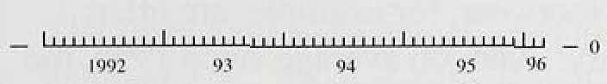

**Chast '1.2:!**

**RP.IY inflation by.sector.**

Underlying *i!*ii*Rction* was broadly constdfit rn the. first

.three months ,of this year. The Government’s target

!measure, the twelve-month change in retail prices excluciing mortgage interest payments (RPIX), was 2.9% in March, down from 3.0% in December. This small

.réductfirnlreflected a decision .not to raise excise duties last year by as much as in the November 1994 Budget. The twelve-month increase in RPIY, which removes all iridfrect taxes.as well, remained at 2.5% (see Chart 1.I).

Unexpected price movements over the first quarter were offsetting. On the upside, house *pTlces* rose al on annualised rate close to l09o in the first quarter of 1996, according to the Halifax Building Society. These have

.had a ldirect impact on the RPI since February 1995, when!an estimate .of housing depreciation was first

.introduced. .But.this component has been erratic from month to month—in part a reflection of measurement difficulties. On the downside, the discounting of consumer durables, notably clothing and footwear, was

.deeper than expected over the New Year.

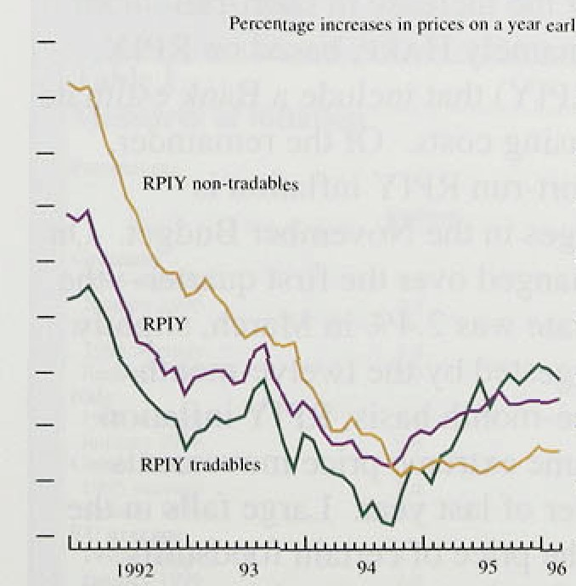

— i Within .RPIY, those goods ,and services which are

_ , commonly ttaded internationally can .be separated from

_ those which are not. Chart 1.2 shows that RPIY iriflatjon rose steadily during the first half of last year.

.dri.ven.:almost entirely by.a marked.acceleration in

— • ..: .tradables prices, Non- tradables inflation, which rose at

.am.annua! rate. close to .l”&o for:most of 1995, has picked up in: recent.month s.

.affeétéd by'large movements in a feW component prices. Often, these are.transitory for example. .low crop yields bro:ight on.by last sui rner's drought.led to a sharp pricies .of seasonal foodstuffs, but only **until** Oétober., Transitory shocks drive a wedge between recorded‘and underlying inflation. At other times, extreme price changes may'reflect a series of earlier clost



iiifrequentl.y. Where..t1iese’ reviews! are..éoncen nated in **particular mon8ls,** further distortions. can arse:. To avoid making subjective judgrñents.:about!sueii:effects oii a.



Inflation Report May 1995

Chart 1.3

Pleasures of c‹ire inflation

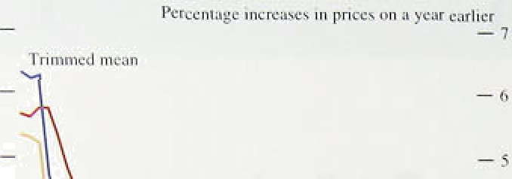







monthly‘batts, the Bank ppliei a fixed rulé to"denve two indices w1 ich limit the influencelof large price movements.,. ;One-month inflation rates are calculat d for 7,7 components, of RPIX. They:are then wéighted and ranked ñy.size.. The median is.that:percentage

.increase:above.yhieh !one hal’f of the resulting distributionl lies, wliile a ,7.0% trimmed mean excludes just the largest and smallest 15 , of price changes.

Chart 1.3 shows that core in!flation, measured.i!n this , way; ofteri 1!ies below aggregate .RPIX. This is .because the distribution.of priée!changes tends!to be skewed upwards, so that.outly.ing price changes are /frequently

.both large arid positive. After'removing:snme of the volatility in published data by tliis means; it.appears that. underlying inflation.may,.havelipeaked towards the end of last year.

"l’ahle 1.A

I @5 1g96 _

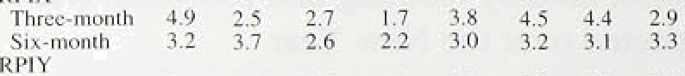*Fch.* Mfg Atlg.. Nov. Dfc. Jan. fcb.. Marr .

|  |  |  |  |  |  |  |  |  |
| --- | --- | --- | --- | --- | --- | --- | --- | --- |
| RPI |  |  |  | | | | | |
| 5ot•muiJlh | 4.11 | 4.5 |
| Three-n onih | 3.0 | 2:6' | 2'.7 | T .'4 | f.8 | 2.8 | 1. f' | 3:0. |
| S\x-month HA RP | 2.2 | 2.8 | '2.7 | 2. I | 1.2 | 2.4 | 2.3 | '2.4 |
| Sis-month | 2.5' | 2.8 | 1.7 | i .8 | 2:8 | 3.2 | . 3:3'. | 3:'6’, |
| THARP  Ttrce-mon t{i | 2.2.' | 1 :8 | I .4 | 1:9 | 2.0 | 2.9 | 3.8: | :4:I. |
| Si z•month | 1.6 | 2.ti | 1.6 | 1.7 | 2.'1 | 2.6 | 2:8 | 3.0. |





A number of prices vary i.n a predictable way over the year. Clothing and ,footwear, for example, are ofiten discounted in January,. A.nd,.on average.sinc.e 1990,’the: ’price of.unprocessed potatoes has.risen by more tlian.

40'7o in August. .So.tit is'customâiy to measuré inflation on la twelve-month basis. iBut this obscures recent price developments. In response, the Bank.seasonally adjusts a numñer



measures. as in ’Fable 1.A.

year., This accounts for the i.ncreas‹ein slioit-run rrieasures of iriflatioh (namely.HnRn, based.on.RPIX, and THARP based .on RPIY) that .include a Bank estirriate of owner-occupied housing costs: :Of the reiriainder,



unaffected..ñy.’tax ehahges.in the November Budget.. On balance!! it was little changed over the..first.quarter—.the



##### six-monih!.annualised irate was 2.4&.in March, slightly

below that, amount.suggested by the twelve-month comparison., Ofi.a three-montñ basis, R:PJY .inflation picked up, owing to some.extreme pprice movements. during the fourth quarter of last.year. .Large.fa11s:in the cdst.of insurance and the price ofcertai.n foodstuffs combined .to rñake .the October price.1evél uniisua!l.ly low. They have. now.droppe‹J out of the calculation.

O.n 20 M'arch, the!Govemment!annofinced a potential 1.ink between!.Boy:ine: Spongiform Encephalopathy (BSE)

:aiid tfie human!condition known as Cir iizfeldt-Jakob

.Disease.:(CID): Subs quently, consumers nought less.

!tieef, Substituting alternatlves such as. poultry, lañibi pork

w

prices..begs:a n!se, b

u h 9b.bet

n’‘ '



*he 'r ii ‹lr vr lofwu'ut.s ill ii ifliili ii*

### Harmonised consumer price,indices in the Eu:ropean Union

. . .

Rurostat, the statisucal agency of the European

Union, has been askéd to produce comparable consumer price indices for each’of the EU member states!. These indices lare being deve)opefi in order to assess the degree of inflation convergence in the approacii.to ecoqomic:and“monetary union. .Because there

Oll i S

measured b .edc f the mn her staten e

’.pro;luction. of ’harmonised'.consumer.price



pu:blished tlie. results.Sof Stage I .of„this pro)ect— the.Jnterim .Indices of Consumer Prices:.(HCP.)

.at the begin.iiifig of this: year..

Tlie IICPs..have been eonstru”c‘ te‹i.usi’n”g. existing. national .data. They simply excmde expenditure items tliat‘are not,tieated commonly in all of the member states’ measu'res ofiinflation. Table 1 compares differences bet\veen national inflation rates an‹i IICr inflation for .the largest EU egonomies. .Differences between the two inflation .rates depend'on. how .prices! excluded from the ’HCP’behave relative to the prices of included items.

**7’ubl’e,l**

Measures”of **inflation**

P.cfcerircgcs

**ltCP**

.exclucled items. Otlier items excluded .from the HCP inclu‹ie education, ,financial services, health. and foreign‘holidays. QC.hart .A shows that there were only small divergences between RPIX inflation ahd IIcP inflation between January 1995 and September l9é5. !Since then, HCP in.flation .lias: been,h.ig1ierthan RPIX!.iiiflation.

This largely reflects!the exclu.sion of insurance costs, which have .bgen increising at a much slower.rate than the included.items. The differences between IiCP inflation .anfi RPI inflation have been more marked, .reflecting the effect of changes i!n interes; rates .on mortgage interest payments.

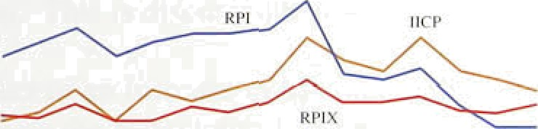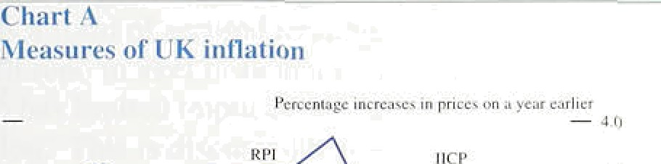

f1.I i

'' fiirmiiiiy



ry , eca

Uâ;erage’’)



 



2:9

 

expenditure items, and (ii) they do not embody the changed method of construction.that..is required for:compl'ete harmonifition... These more fundamental changes will be u!ndertaken as..pan oftstage II.of the .project, and relaté to

For the,United Kingdom, a:bout 20,d of tlie



gxpedditure items in the. RPIihave .been. excluded from the HCP. .£tousing-stated expénditure (such ae mortgi;ge. teiest payiñenfs, counci1ehants,. dwelhqg insurance and depmoigopn) account fnr„tfio majorty of.be

measurement issues such as the frequency of rebfl.Sing, the construction of iqdex. numbers:and the inanner iri w.liich quality changes are accommodated—as well,as the inclusion of all. expenditure items. 1Stage II consumer price indices will nOt’be released until early 1997. ’

Rec i o I 996



**t*hangcs in expenditure Jcf1aturs (market yrices)**

C'unsunig- Invest- G ›yem- Domestic tion menj_ tnenf ‹ demand lb›



Q?onQ? t).4 1.2 1).7 0.;5 0.7





8.

to one supermarket source). This. hañ ño.iinpact o,ri the.March RPI data, co1lecte‹i.before ihe Ciovernment's:an:nouncement.

expecte‹i!by mid-1996. As..noted,above, the price of some tradable:.goods lose:sharply !ast year.. This:effect is set to. drop out of’the twelve-month comparison.and is likely more than to offset!rising:ineat prices. in.April,. there was additional dow.nwârd pressure on annual RPI



.inflation, reflecting rate cuts by a .number pf mortgage lenders at the beginning of tlie.month, and the’fact iliat. last year’s cut in.mortgage interest relief was no longer included.

#### 1 2 E e d t e e o

The GO.P deflator anñ its.components measure.the pnce of domestic valiie adde‹i, arid so provide a inore comprehensive,. but 1ess\t'imely,'inilation,measuy...than the retavl prices ind.ex. The.GDP deflator rose by 0.4hc in 1995 Q4, ei›rripare‹i:with 0:3&o. ih›Q3: Tliis: modest acceleration was.partly. due to improveii export profitabi!lity. Table:1.B: sliows that impon..and export

.deflators increased sharply in tlie.,fourth quarter of,last y,ear. as sterling depreciated by 0.91a. This .resporisé .is consistent with.bthe price of interiatioiially traded goods being set on world markets, !over w.hich UK priiducers 1 have little irl.fluenc1e.

## 1 3 S

RPIX inflation was broadly:unchanged.in:the..six months. to March.at around 3!%. a.year.: 'But.large pne.e.falls recorded..towards.the end.of .199a mean that a .number of short-run measures.edged'up at thé!.beginnifig.of l99ñ'.

When ou11yin.g price!changes. are remov’ed, ,the recent stability of iinder1ying'i.nflation is confirmed..

**Money and interest rates 2**



J,an''.”. I :2 :I0.'4

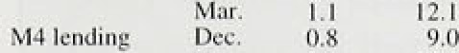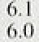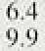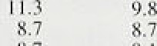

'.M4.



Soiiii›i: . B' ink':gif-F nytanJ : t at Seasonally iiljiis en

' (c).,',-PrOv“i'sion‘ati.

U2 M e n e t



Twelve-month broad money growth (M4) was 9.5% in M:arch. compared with 9.7% in December, the latest month for which daia were available at the time of‘ the February *Reyorl. so* it has remained above its 3Ur—9°/. monitoring range. M4 increased at a three-month annualised rate of 1. 2.1& in Mai ch, up frorri I O..5°J in December (see Table .2.A): the acceleration was accounted for by gilt repos (see the box). A gilt repo is a form of deposit secured against gilts. while a reverse repo is a .form of secured lending. The introducti.on of the gllt repo market in January was a structural change which has limited .iiiipIications for future activity and inflation. This is discussed below.

The. effect of .an increase in M4 on nominal demand depends on the behaviour of its velocity of circulation— that is,. the speed at which M4 cii’culates in the economy. The velocity of M4 rosc slightly in the recession cif the early 1980s, but then fell sharply over the f’oJ1t›wing deca0e as a result of financial liberalisation. Duri rig the early 19.90s, velocity stabi1.ised, but between 1994 and 1995, M4 velocity declined by a further 2.S*/e.

.On the *der?tniid* side, broad money is held both t‹i buy goocls and services and 1as a store of’ wealth. An inci eiise in broad money resulting from greater planned spending by!iñdividuals or companies would .signal an increase in nominal demand. But, for any given level of financial wealth, a shift towards broad money front less liquid

.asset:s. could 5imp!y be.a portfolio xwitch in response to Changes in expected risk and return.

The Joyyf y *of* firoad .money depends on how banks .ind building societies increase their assets. including loans to'tlieir customers. An increase .in lending could reflect

:increased demand.!for credi't‹from customers. Or it could reflect i:ncreiised willirigiiess by banks to supply credit at



(t)Ut1t9s @‹hei isz7sRtt4, ie£R0tnccsl oJxinL *tnd building: s‹x:ic\}' lci\‹)in¿



















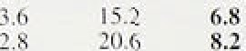

l0gC Ql 7.(T ZJ







Q3 4. 0 Q4 3:3 ’f

|  |  |  |
| --- | --- | --- |
| t.7 | 212 | ’97 ’ |
| 7.? | 23,3 | 9’.8’ |



..buil‹iiiig societies have .to: attractor more deposits; so tlieir. assets.and. liabilities increase i!n ,t'andem.

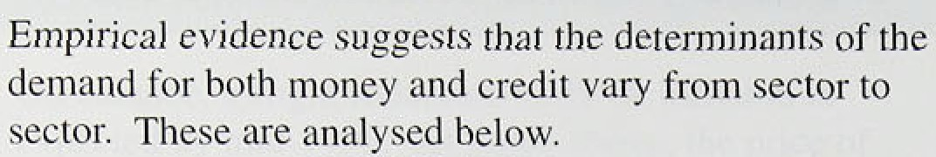

Individuals : deposits increased by 1..69c in the .first quia/rter of 1996.. Industrial And eominercial companies’ (ICCs) deposits rose by 2.2&o, while the deposits'of other, financial institutions (OFIs).increased by 7âu. Cliart 2.1 shows, tlie. prpportions!of the stock of M4. accounted foil by each sector:.

*Personal sector*

Individu'als’ deposits grew faster in .1Sfi5, and deposits rose by £fi.1 ñillion’!i:n 1996. Q1, Thefr foiir:-quarter growt!h' rate: was 7,39ai.iti: 1996 Q1., up. from..7.09• i.n 1993 Q4 (see Tañ1e1..2.B). This compares. with'nominal

income growth of 4:.1 *No* i.n 1.995 Q4.a!nñ 4.7%-growth in norriinat co:nsumerr sspeenndiinn:g

. . . . .. . „ . ..

The increase i!n. indrvrduals ‹deposits in 1996 Qll

occurred ldes!pite.the”(act that arouqd £17 billion. of Tax Exempt Special Sav;ings Accounts (TES5As). rñatured ‹iuring the quarter. Since the interest.on

maturing TESSAs:‹iarinot fee p!ac.ed in ’follow-up TEsSAs; some of it was are-m;veste‹i in non-M4 long-terrii savings pro.ducts; such .as.Natiohâl‘.Sa ings and Ntai.l'uñi!t tnists; deposits, in these alsp increased sharply.

Tuts I personal sect‹›i financial assets and





 

The .i.ncrease in personal isector deposits (which also' include ,those ofi unincorporated'businesses) does .not appear ,to !reflect a..siiift in financial ponfol.ios.towards. M4. Rather it reflects faster. growth .in!total financial assets: these i.ncreased by..over .15a in,the.year to 1995 Q4., Bank an‹i building society deposits,have.been

' . . fallin as ia propoftioniof the personal sector's total

p financial ’assets since 1552 (see Chart.2.2.and

Table 2.C). 'The personal sector’¿ net financ’ial.'wealth ”' has over .20%. higher in 1995! Q4 than .a, year'earlier.

° The’risk to’nomiqal demanñ is that people iriay use some

„, of:their, increased .finapciaf wealth to biiy more goods afi‹1services.

"* The articlé ‘Understanding broad money’ in the May

_ , lâ96..Oxorierfy *Bulletin* explores these possible motives for increasing deposits in banks and building societies.

.It concludes ihat it is implausible to attribute the entire







S'ti›ck i›f Hank anal.liuildiiig society:credil.



OFI¿.









Cliiinucs in him h antl tiuilditsg s‹›ciets lending





1 "i0f› Q1 4.8 I i.8' 1. 3.9' I fi. 2 0.1

C t›tiIri h ut ions It› :innu*tl pruwth in bank arid bu ildi rip











Chi rt 2,b

fi r‹›ss th *rntex* r›f persun‹il sector bormsting







*Personal sector*

Lending to the! pérsonal sector by banks and building societies started to, accelerate ñiode.stJy. in riufi-1993; ts.. twelve-rrionth growth rate reached 6.4,% in 1995 Q1.



bétiveen secured lendihg (rfiainly .mortgages); which ma!kes up 8.0% of the:total, and›unsecured lending (consiimer ctefiit), which. make.s up!.most of the rest.

decelerati.rig steailily since! the beginning of 1994, while consumer credit has .been: 'ñccelerati.ng (see Table’ 2.E and Chârt 2.6):. To some



.extent, th.is divergdnce.inay réflect substi.tution frorñ secured to unsecured Iendin the weakness in!thé housi.rig marLet the'i.nerease in house prices oxer che..past nine months has not yet fed.through.







reflect the différent borr0winy behaviour of separate

,groups..of! consumer...

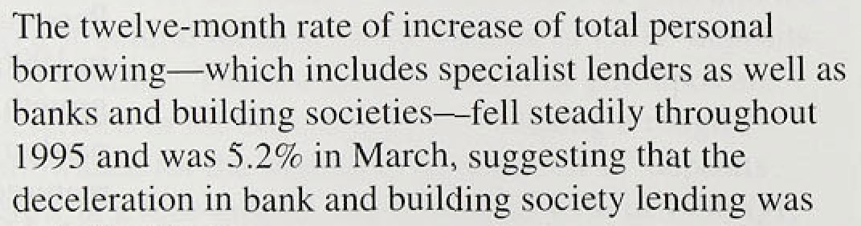

other:

Short-run.measures of total personal borro,wing,suggest

.tliat its .growth.rate .has started to stabilise recently. Tire threle-month anrtuallsed .growth rate was also.5.2&‹ in March, !simi1ar to its..rate over tlie past.five 1.months.,

*I!ndustr’ial! anâ.e’ommé’rcial i:ompanies*

*ICC*s' borrtiwing increased ñy JS:.9& in the foiir q!uartérs: to 1996 Q1, its stron:gest!growth rate .for five years. It•was .not offset by any decline in capital issues



.(see Table 2.F). Indeed, the stock of ICCS* bank and buil0ing-society .borrowing has been falling. rela:tixe to



Storm ' *yyJ.iiiter.e I mtce*

lneir total financial liabilities since.the end of 1990 (see Chart 2.7).. The growth of ICCs’ borrowing prob.ably reflected a one-off increase .in the demand for

credit to finance mergers and acquisitions. This does not

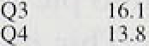

6.k

2.6:’ ’24.6’’

an increase in spending on goods and services, although an increase in takeovers may itself reflect a strong stock market, which makes investment less expensive to finance. But it does. imply that the growth of ICCS’ borrowing should fall as mergers and acquisitions stabilise.



*Other financial institutions*



.OFIs’ borrowing from banks and building societies

.staned to accelerate towards the end of 1992; its growth rate was 16.29 in 1996 Ql. This did not represent a portfolio shift into bank and building society borrowing:

.OFIs’ other liabilities grew more quickly over 1995 (see Table 2.D).

As wtth the asset side of the balance sheet, OFIs’ borrowing was affected by the IntrOduction of the gilt repo market in January. The box describes how OFIs can borrow from banks using gilts as collateral (banks’ reverse repos). Additional borrowing by OFIs against

!gilts increases M4 lending. Adjusting for this structural effect in.tfre first quarter, OFIs’ borrowing rose by aroun‹i 1.1% in the four quarters to 1996 Q1, suggesting a slowdown in its rate .of increase. Total M4 lending



 increased by around 8'/2Wo in the year to March, once the structural effect is excluded, a little more slowly than in the year to December.



***Suppl )› o!f*** *credit*

Broad money .growth may reflect changes in the supply of credit by banks and building societies at any given interest rate. One way of measuring competition for fundsl in ,the .banking system is to examine bank spreads. Narrower spreads an‹i margins are likely to increase the volume of intermediation undertaken by banks and **building societie** and so to increase M4. Bank data on i.nterest rates acro:ss a .variety of lending and deposit insptutions..show that, on average, spreads stopped



1:993..Q2. and ivifiened slightly over the



,:Mortgage rates have.fallen further.sihce,the February



 First, official rates—ând !hence sh9rt-feiTri rñoney-market.rates-were

.cut. 5ecoñd, lenders becaine increasirigly willing to redoee rates **km new.iaistomeis: Chart** 2.8 shows. that



"

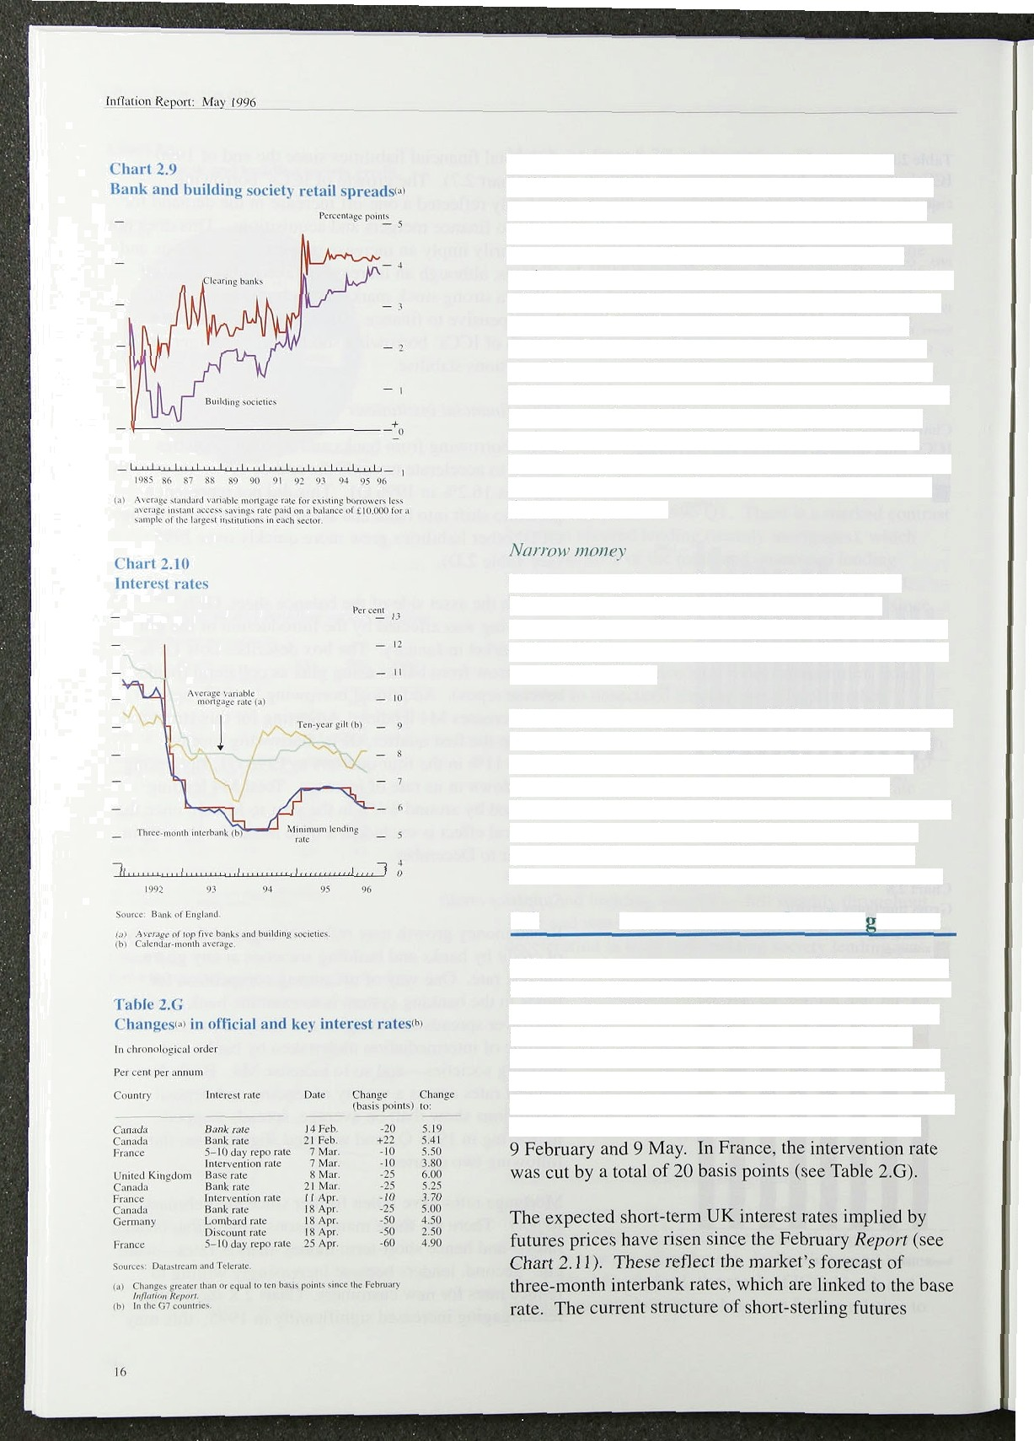have continued in the first quarter. Third, certain building societies have sought to assert the benefits Of mutuality by cutting mortgage rates for both new and eKistirig borrowers. Building society rei•ail deposits may have been less sensitive to rate cuts, because some societies have announced future conversion to plc status, which will result in compensating payouts. This might have allowed building societies to preserve interest spreads. In contrast, some of those building societies remaining mutual have increased deposit rates. Faced with risinp• deposit rates and falling mortgage rates from some competitors, bank mortgage spreads have been under pressure. Chart 2.9 shows that the differential between building society mortgage and deposit rates has risen, as building soCieties reduced deposit rates more than mortgage rates.

Narrow money has accelerated modestly since the February *Report.* Notes and coin increased at a

three-month annualised rate of 6.7% in April, compared with 5.1% in January. The twelve-month rate of growth was 6.29a in April.

The twelve-month growth rate of M0 was 5.6% in April. Its growth rate has been above its 0%—4% monitoring range for three years. As inflation falls, so does the opportunity cost of holding cash relative to bank deposits—the bank deposit rate—increasing the demand for cash. It seems increasingly likely that the strong growth of MO increased demand for cash relative to other forms of wealth in the lpw-inflation environment.

### Interest rates and exchan e rates

Official UK interest rates were cut by 25 basis points on 8 March to 6.0%. Chart 2.10 shows some of the interest rates paid by different UK borrowers or used as a basis for calculating their borrowing costs. In the United States. official interest rates have remained unchanged, while in Germany the Lombard and discount rates were cut by 50 basis points on 18 April; the German repo rate

—the official dealing rate—was unchanged between

**Chart All** . . ’’



suggests that,. on balance, .the markets expect rates to remain broadly unchanged over the next three months, ’but then to increase by around 40 basis points by the end

, of the year and by around 130 basis points by mid-1997. ”’ .At!the,start of the year, the markets were expecting a

25 basis-point cut in rates in the first quarter; rates were

.expected to rise by around,50 basis points by inld-1997.







**Three-iñonth”inte.rest ratis.** ’

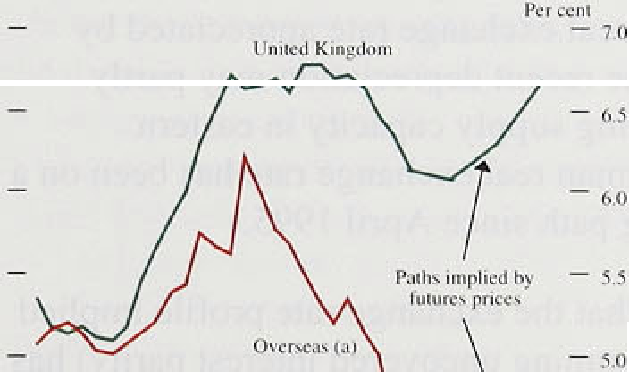

**Chart2.1:3'**

**.Clians es'lñ nominal'.forward.:inte.reat** rñtestsi'.







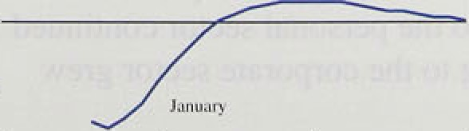

Interest rate expectations in the United Kingdom ’s major trading partners have also been revised up, although by less. The gap between the interest rates implied by the September three-month futures contract in the United Kingdom and Germany widened by 41 basis points b.etween 9 February, when the February *Report* was

.finalised, and 9 May. The UK-US differential narrowed

.from 102 to 36 basfs points. Chart 2.12 shows the path for the interest rate differential between the United Kingdom an‹i its major trading partners implied by futtires prices.

Chart 2.13 shows the change in expected nominal interest rates in the gilt market immediately before and after the January and .March cuts in official interest rates. The profile .of expected rates fell over Short horizons after the 25 basis-point cut in rates in January, but was slightly iii.gher after about ten years; but it rose following .the 25 basis-point cut in rates i.n March.

Ten-year yields in the United Kingdom rose by 89 basis points between 18 January—when yields reached their lowest level for about two years—and 9 May. More than half of tire .increase occurred after the February *Repo.r.t.* The article on G7 yield curves in .the *Quarter !y* ***Bulletin*** uses a method to measure consistently yields at dlfferent maturities across countries. Since the February *Report* was finalised.on 9 February, ten-year nominal forviard rates have risen by 94 basis points in Canada.

in the United States, by 35 basis points in Géima:ny:an‹i by .18 basis.points.in Japan. This compâres with:an..increase of 18:b1asis points in the United King‹iom. .in Italy, forward rates have fallen by 39 basis, points,and in France they are down 6 basis





The. effect of a rise in.!bond yields depends on whether the expectéd.real interést!rate or expected inf1ati.on has risen. In.the United.Kingdom, it is. possible to ”distinguish between'tliese al.terñatives by analysing the diffe‘rentiâl between conventional and index-liñked. bonds. Measured!. UK:.in:flation expectations.have nsen

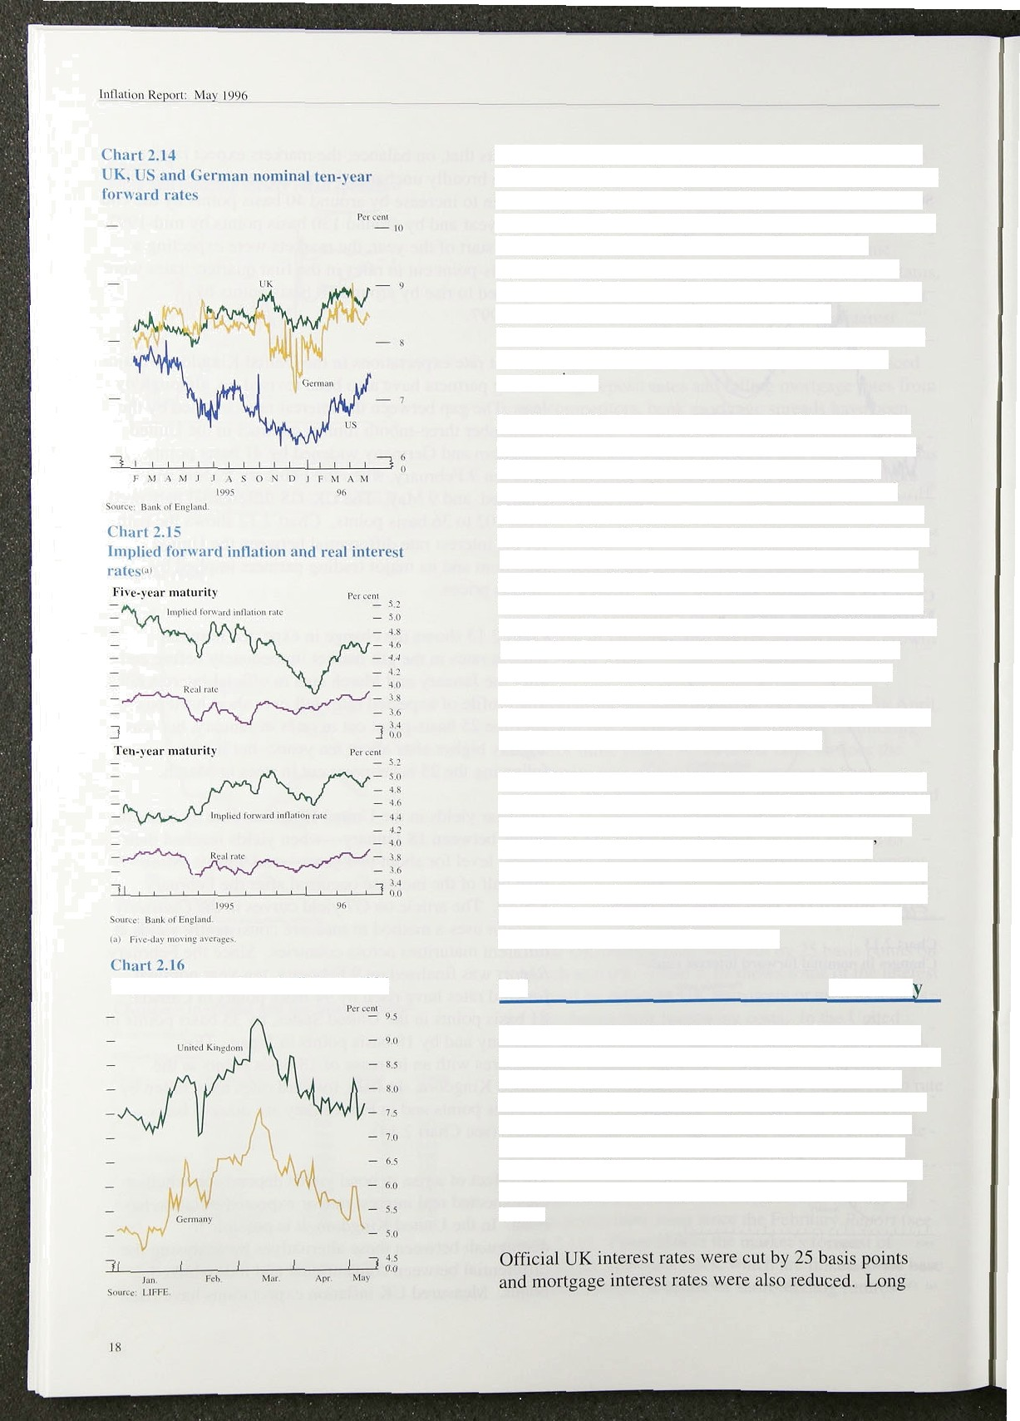

**l iupl ic‹l** lii›iuI iuiii ket s tiliililities in 199f•

at both five and ten-year maturities since the beginning of the year, although implied forward real rates have also increased slightly (see Chart 2.15). Measured inflation expectations also include an **inflat)Ofi** *Ti$k* r8fTlium, so ii is also possible that this has risen. Bond market volatility may provide a proxy for uncertainty about inflation. This increased sharply in February and early March before falling back (see Chart 2.16).

Nevertheless, greater perceptiOns of risk are unlikely to explain much of the increase in measured inflation expectations.

Sterling’s effective exchange rate was 84.4 on 9 May, 0.47c higher than on 9 February. While the pound has fallen slightly against the dollar, it has risen fairly steadily against the Deutsche Mark since the end of October last year. The German effective exchange rate depreciated by 4.7% between its recent peak in October 1995 and 9 May. German unification led to a nominal appreciation of the Deutsche Mark in order to facilitate the increased net inCow of real resources necessary for investment in eastern Germany. Between 1990 and mid- 1995, the German real exchange rate appreciated by almost 23%. So the recent depreciation may partly reflect the developing supply capacity in eastern Germany: the German real exchange rate has been on a modestly declining path since April 1995.

Chart 2.17 shows that the exchange rate profile implied by bond yields (assuming uncovered interest parity) has been revised down slightly since the February *Report* was finalised. This profile depends on countries relative inflation rates expected by the markets over the long term. So it reacts to economic and political events in the United Kingdom and abroad, as market views change about relative inflation rates.

### Summar

Broad money growth stabilised in 1996 Q1, just above its 3%—9% monitoring range, but the four-quarter growth of individuals’ and ICCs’ deposits increased further.

These could signal an increase in nominal consumption and investment. OFIs’ deposits and borrowings were increased by the introduction of the gilt repo market.

The growth of lending to the personal sector continued to moderate, but lending to the corporate sector grew faster.

iW‹zr •r urizJ iiif‹•i‘*,vl rr fc.'

Chart 2.17

UK effective exchange rate profilest*





’Soume;: BTS,DM lmgmzndBznLoCknjand. C} *4numi»g«n* nwmJ*pmmrJ ny.

.bond yields rose in the United Kingdom, the United States and Germany. Short-term UK interest rate expectations were revised upwards.

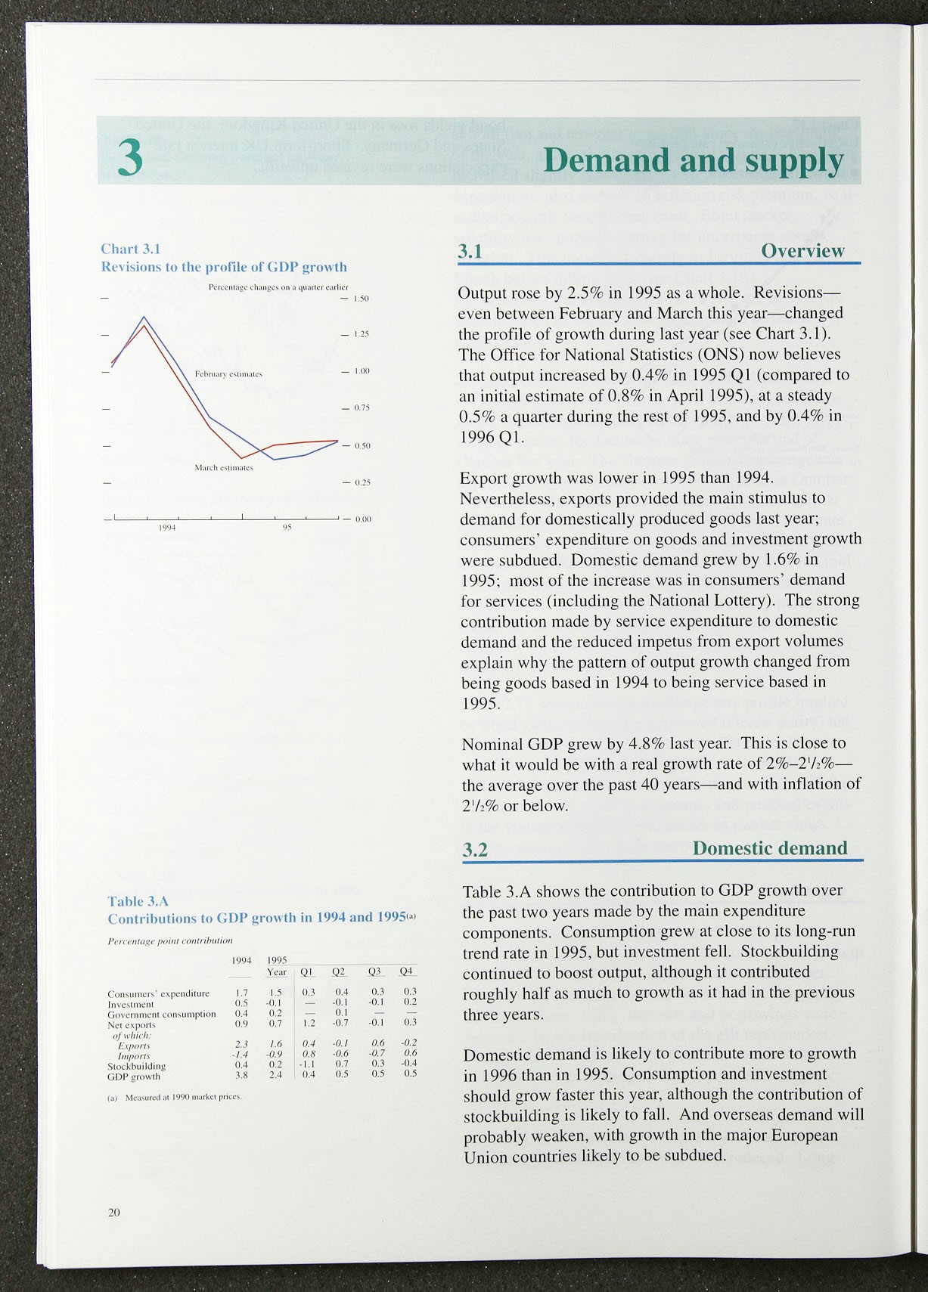

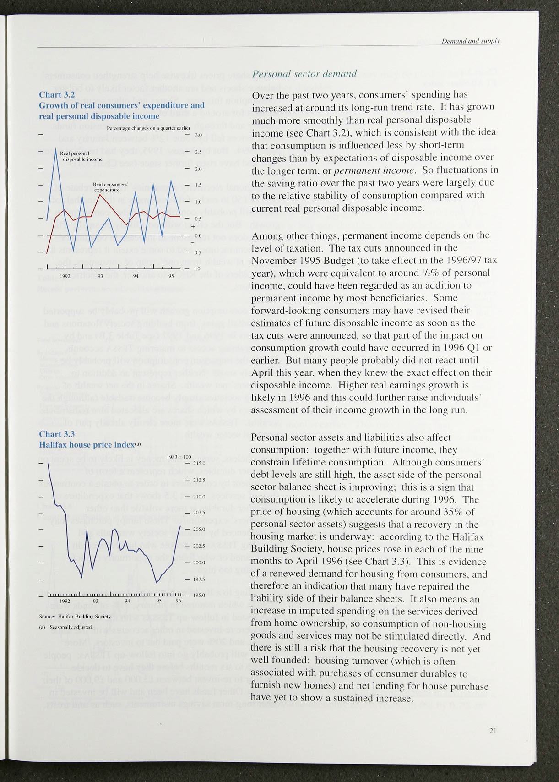

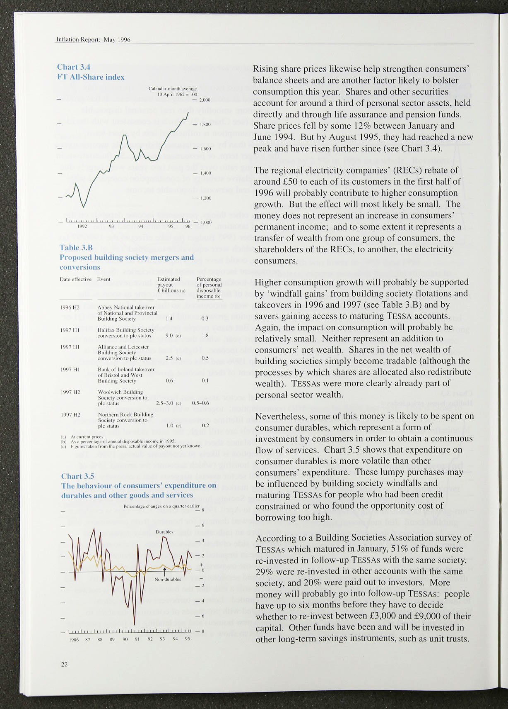

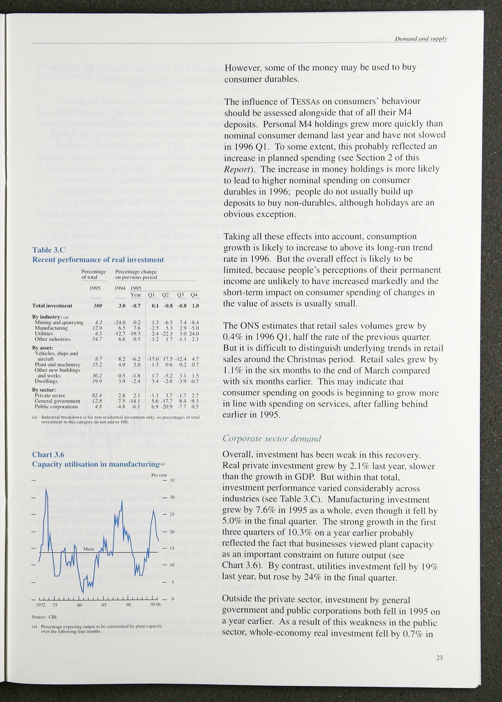

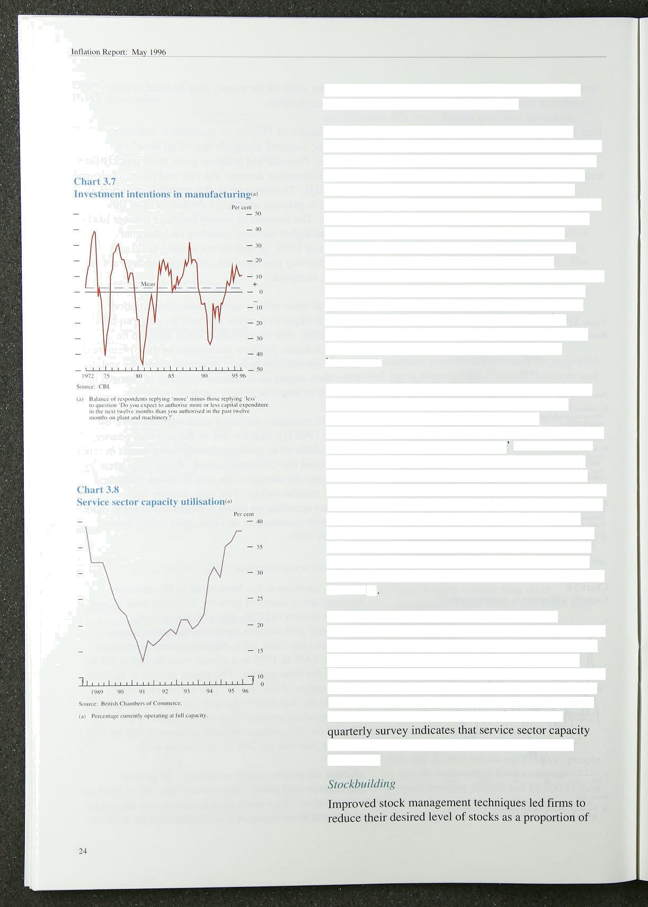1995 compared with 1994 (the effects of the Private Finance Initiative are discussed below).

However, the conditions are favourable for private sector investment in 1996. Profitability is still high, and rising share prices have increased the incentive to issue equity to purchase real assets. Moreover, the current strung growth in ICCs’ M4 deposits could indicate higher planned fixed investment as well as more merger and acquisition activity. And leasing companies have recently increased their borrowing. The Finance Leasing Association, the trade body that represents leasing companies. suggests that this reflects a

substantial increase in the purchase of investment goods. Leasing companies buy investment goods in order to lead them to the end user. For the user, leasing is an

‹alternative to borrowing. To some extent leasing companies may be increasing their market share; but their higher bori owing could signal an upturn in investment.

It seems likely that manufacturing investment will not grow as quickly in 1996 as it did in the first three quarters of last year; with the slowdown in manufacturing output growth in the second half of 1995, capacity utilisation fell, so that firms need to invest is probably not as pressing as at the beginning of 1995.

However, although it fell in the final quarter of 1995, manufacturing investment is likely to grow once again in 1996. The percentage of firms citing plant capacity as a potential constraint on output in the CBI survey has declined. but it is still high by historical standards (see Chart 3.6). And the balance of firms in the latest **CBI** survey expecting to increase their investment in plant and machinery remains above its long-term average (see Chart 3.7)

Private service sector investment will probably accelerate in 1996. The increase in service sector output over the past three years has reduced some of the spare capacity that was created by the combination of the investment boom of the late 1980s followed by a serious service sector recession: output of services fell in both 1991 and 1992, the first consecutive annual falls since the 1940s. The British Chambers of Commerce

utilisation has increased markedly since 1992 (see

Chart 3.8).



output!.over the l!980s and early 1990s. More recently howeveri the! stock-output ratio has cl.imbed (see



!Chart.3.9). .How firms react to their current level of lstocks ,wiii have an important bearing on the prospects for::economic acti:vity in .1996. A key factor wi.11 be

.whether.increased stocks are now. held voluntarily or not.

Firms,ean. hold stocks of material inputs, work in progress, and finished goods. Firms want to hold stocks of finished goods, because they fear losing profits by not being able to meet unexpected increases in demand.

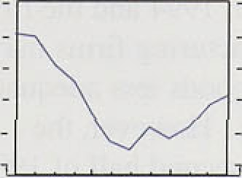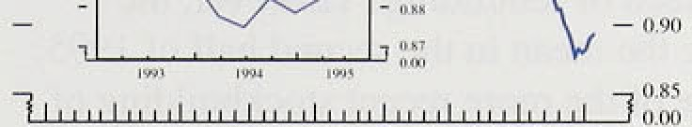

Thua.firms' desired stocks are likely to rise when uncertainty about sales increases. One way of capturing uncertainty is to look at the volatility of sales.

Chart 3.10 shows the quarterly percentage change of manufacturers' real sales. This indicates that sales in the early **1990s** were less volatile than in previous periods, so it seems unlikely that manufacturing firms’ uncertainty about future sales has increased in the recent past.

Stocks of raw materials and other inputs can provide insurance against a shortage stopping or slowing the pro‹iuction process. The large increases in manufacturers’ iriput prices during 1994 and in the first half of 1995 may.have increased firms’ desired holdings of raw materials and fuels stocks. Manufacturers may haxe interpreted the price rises as signalling possible supply‘interruptions and held higher stocks as a preiaution.



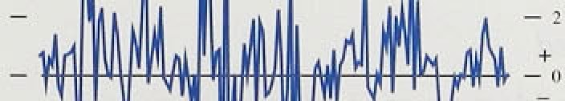Holding stocks is not costless. .Firms have to pay for the physical storage space and financing: other things being equal, falls in .real interest rates will cause firms to in'crease desired stocks. The real interest rate by which firms ineasure the cost of financing stocks depends on tfieir expectations about increases in the price of those

.stocks.. .Rea!1 interest rates based on expectations of

.appropriate-.price indices for stocks are not readily



.available. .However, the cost of financing material input

:Stocks ivi.11 have fallen in the past two years if firms anticipate‹i.some of the rise in input prices. Unless firms expected significantly higher finished-goods inflation nan actually took place, any fall in the real interest rates affecting *s* th*er* types of stocks would have been

**6ttbstdftti@ly .simmer.:** '



Evpfi **If fifiRs'** ‹desired le el of stocks has not risen, 1992 and 1:993 may have'seen invol:.unitary.destocking or

**.insiifficient stockfiuildin** g ind firms may have tried.to

###### ’i:9n4! nd 1955.



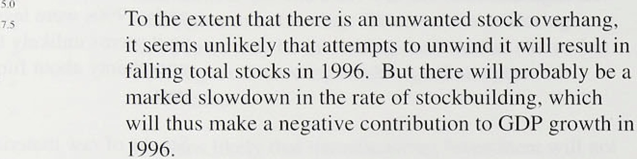



Pt l›lir sectnr cuyital experidittire



on.account of.overall

y.o (,.y y:.j.

n$ i ?.f› 4.(i 4.b.

y,5

3.7

¿ 5.. ¿ 2 ..5 g

.h

..5.4

. ›.

subdued oyer tlie.next threle years.. .According to Ue

.latest!F.inarieial" Statement. and. B:udget Report, general

go,yemment'and:public corporations'.investment is

planned to fall in nominal terms.in edch of the three

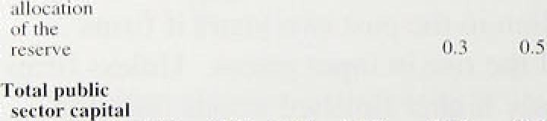

'' fiqancial years to 1998-99 (see Table 3.D). Even abiding in rite estimated outturns.for the PFI„total publicly

*F.siinxutcd*

##### !”’ .

e

##### sored capital expenditure is l.i.kely to fall in. real



Tni‹i:un'c 

The PSB.R in 1995/96. was fi3.2.bi.llion higher than: forecast.in the November 1995:.Budget, largely because of unexpectedly low tax receipts:given lhe.l!e*éJ of

(ca1eñdñr.year) was 6:0& Qf GDP; using the definition’of



##### the deficit specified.in tbe Maastricht ,convexgence

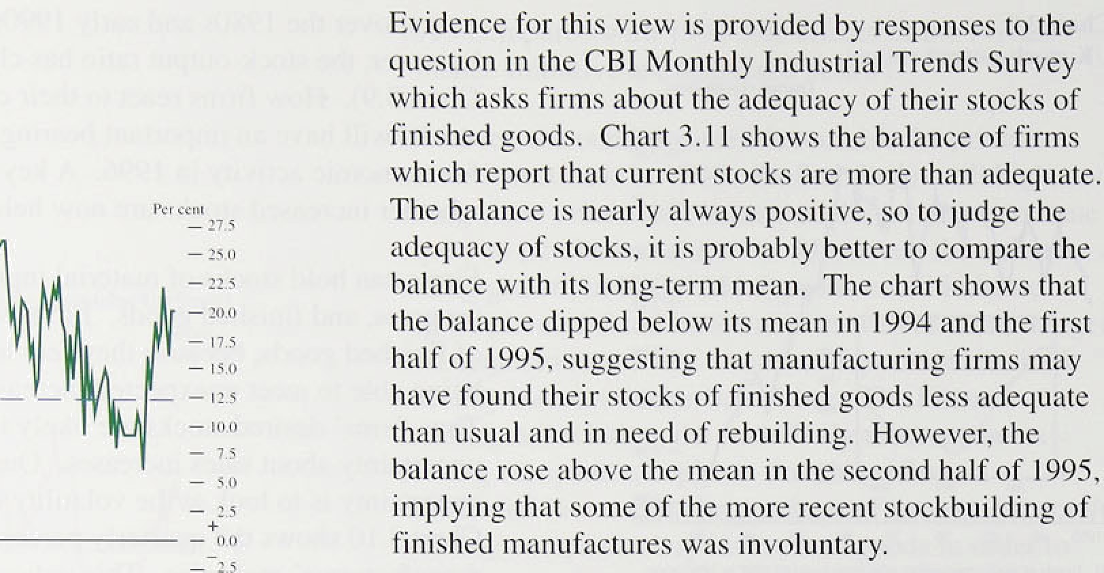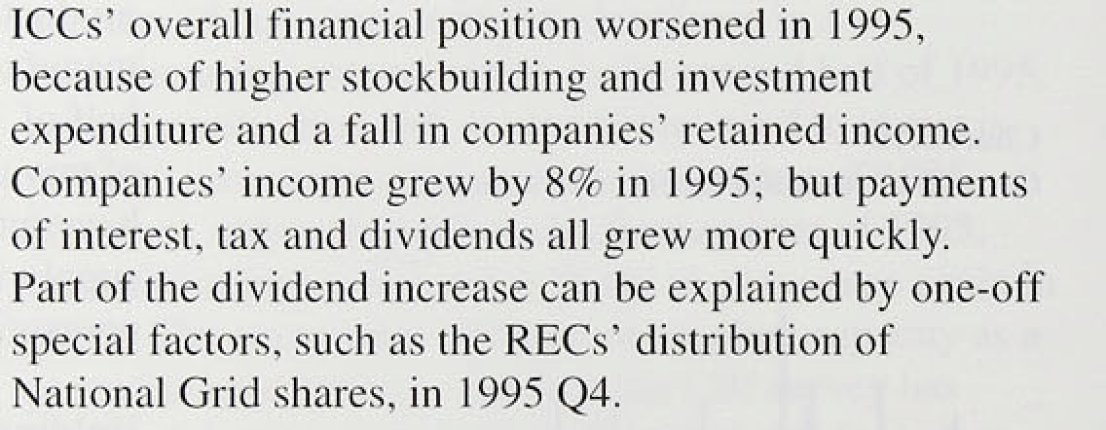





Criteria. The consequences of BSE are likely to add to the:fiscal deficit. other things being equal. But this should..have its.greatest impact i.n 1996.

**3.3 Net external demand**

The deficit on visi!ble trade widened only slightly in 1995. Export and iinporl values grew i‘oughly in line, but expoi t volumes grew .faster than iicpoi t vol uines. Although. tfie United Kingdom’.s main overseas trading partners grew slightly more slowly than the United Kingdom in 1995. the sterling. effective exchange rate depreciated.

Export volumes feJI in 1995 Q4. However, net externiil

.trade made a positive contribution to GDP growth, as imports fell fidster. The fal.l in export volumes in that quartei was accounted for’ by weak EU demand: expoi ts to EU countries fell by 39c. but rose by 3.27r to non-EU countries. Real domestic demand fell by l.l % in Germany, l.07c in France and 0.49r i.n Italy in 1995 Q4. GDP also fell i.n all three countries.

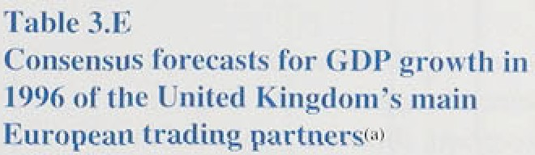

The outlook for’ demand i.n the European Union. particularly Ge.rmany, in 1996 has weakened since the beg.i.nut.ng of 1996 (see Table 3.E). In February. forecasieivs were predicting German growth. tit around  in 1996 oil average. and hy April grt›wth closer to

l % was expected. But it seems likely that many of thesc

forécasts hate not fully i.ncorporated the reccnt weak dat3: The Ger man government’s forecast of O.7ñ7‹, anriounce‹i on 3fi April, is lower.

The current weakness in Europe is likely to be

.temporary,.as groivth will. probably pick up in the second

half!of .l 996.

The:receiit cuts in interest rates, along with

strong.growth i:n rrioney and credit. are likely to support higher fierfiand, e,v.en though fiscal consolidation in Europe: to. meet the Maastricht criteria could off.set this to soine extent::

0oiriestic.demand in the United States also téll in. l99ñ Q4, by. 0:›l %.. But:it recovered in t:he first .quarter of this year, grow.!i:ng . by’’0.9v•'. The: United States is the United **Kingdom's** biggest market outside the European Union (se”e!Chart 3...l2)„ and it!i's l.ikely to gi’ow faster than Europe in l99ñ.



'”’ **The, CBI** Quarté rly 1iidustriñ'l Trends Survey for April suggests.t1iat firrris’ optitni.srn *bout e)xpoq pi spects has

tel Current prices

weakene‹d f urther:

The balance of those onto .are more:



# Measuring the economy

Changes in aggregate demand relative to productive potential affect inflation. So effective monetary policy iidvice requires a set of data that are reliable, timely and describe a broad range of economic activity. This box discusses the extent to which these criteria are met by information available to the Bank.

Naturally, attention is often focused on Gross Domestic Produet (GDP), which measures the output of and expenditure on all UK-produced goods and services.

Provisional data are published quarterly by the Office for National Statistics (ONS) *some* three weeks after the period they describe (tJgures for 1996 Q1 were released on 29 April). The quality of this information is high by international standards—with regard to both timeliness and the scale of revisions, the United Kingdom was ranked joint second in a comparison of 13 national statistics agencies. ' ' Nevertheless, the delay before each estimate is finalised has led the Bank to monitor a range of more immediate, though less comprehensive indicators. The diagram outlines a selection of these, and provides information about their frequency, coverap•e. accuracy and timeliness. It is not meanl to

be exhaustive: many other surveys and data sources are monitored as well. The chart describes coverage of output data by industry. Alternative diagrams, based on expenditure and income categories, could be drawn, which would emphasise other sources.

Each publication is described by a horizontal bar. Official data are shown in red. A number of surveys, made available by trade organisations sueh as the CB I, appear in blue. The importance of the source, in terms of the proportion of value added covered, varies with the length of each bar; the space afforded to four broad industry groups—agriculture, production, construction and services—along the bottom axis is proportional to their share in GDP. Shading is used to provide a crude indication of quality; ranging from dark colours where data are obtained from all firms in a given market, to lighter colours where these are based on a small but representative sample. Monthly releases appear in the first panel, quarterly ones in the second. And data released with the shortest delay appear near the top of each section. To illustrate, every quarter the British Chambers of Commerce sample around 3& of the

non-government service sector and 9& of other firms

(by employees covered). Results for Q1 were published on 18 April 1996, so the relevant bar, coloured blue and lightly shaded, spans most of the horizontal axle and appears near the top of the lower panel.

Official statistics provide only incomplete coverage of the real economy on a monthly basis. Data on service sector activity, which accounts for more than 60a of GDP, are particularly scare the only timely indicator being retail sales, a measure of expenditure mther than value added (see diagram)J2› The production and construction industries are well represented, but timely information on the latter is not consistent with the National Accounts framework. To illustrate. figures for new orders provide an indication of potential activity over a number of quarters, while the housing starts and completions release counts projects undertaken without reference to thgir value. In a recent publication,‹*' the CSO described estimates of agricultural and production output as ‘good’. At the other extreme, representation of banking and the public sector was just ‘fair’. Varying degrees of coverage reflect the ease by which data can be collected.

Because the electricity, gas and water supply industries are dominated by a handful of large firms, their output is derived from a comprehensive censu suggested by the darker shading.

The Bank receives around 30 economic surveys on a regular basis—a selection appear in the diagram.

Al most without exception, these are published in advance of the official data—the **CBI** Monthly Trends and Distributive Trades and the Chartered Institute of Purchasing Supply Surveys are all published within two weeks of the period they describe. The information contained is often detailed. For example, questions in the CB I Quarterly Trends Survey relate not just to output, but also to employment, the adequacy of stocks and reasons for investment. And many have a forward- looking element. A clear disadvantage is that most responses are of the ‘Up’, ‘Down’ and 'No change’ variety.‹*i Analysis is further complicated because many surveys have a short track record—of those described in the figure, only the **CBI** Monthly and Quarterly Trends and Distributive Trades Surveys provide more than ten years of data. And while coverage by amivity is broad, sample sizes can be.soiall.

Additional information is obtained from the Baak’s own contacts. A network of Agents tn the regfpns, soon tn be enlarged (see article on page 198 ofitin en:rrent *Quarterly Brfleiin j,* visit tiiound 4,0% finns egch year.

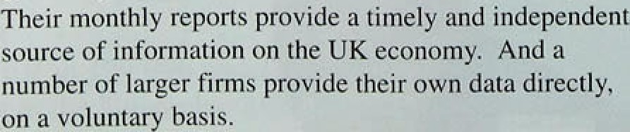



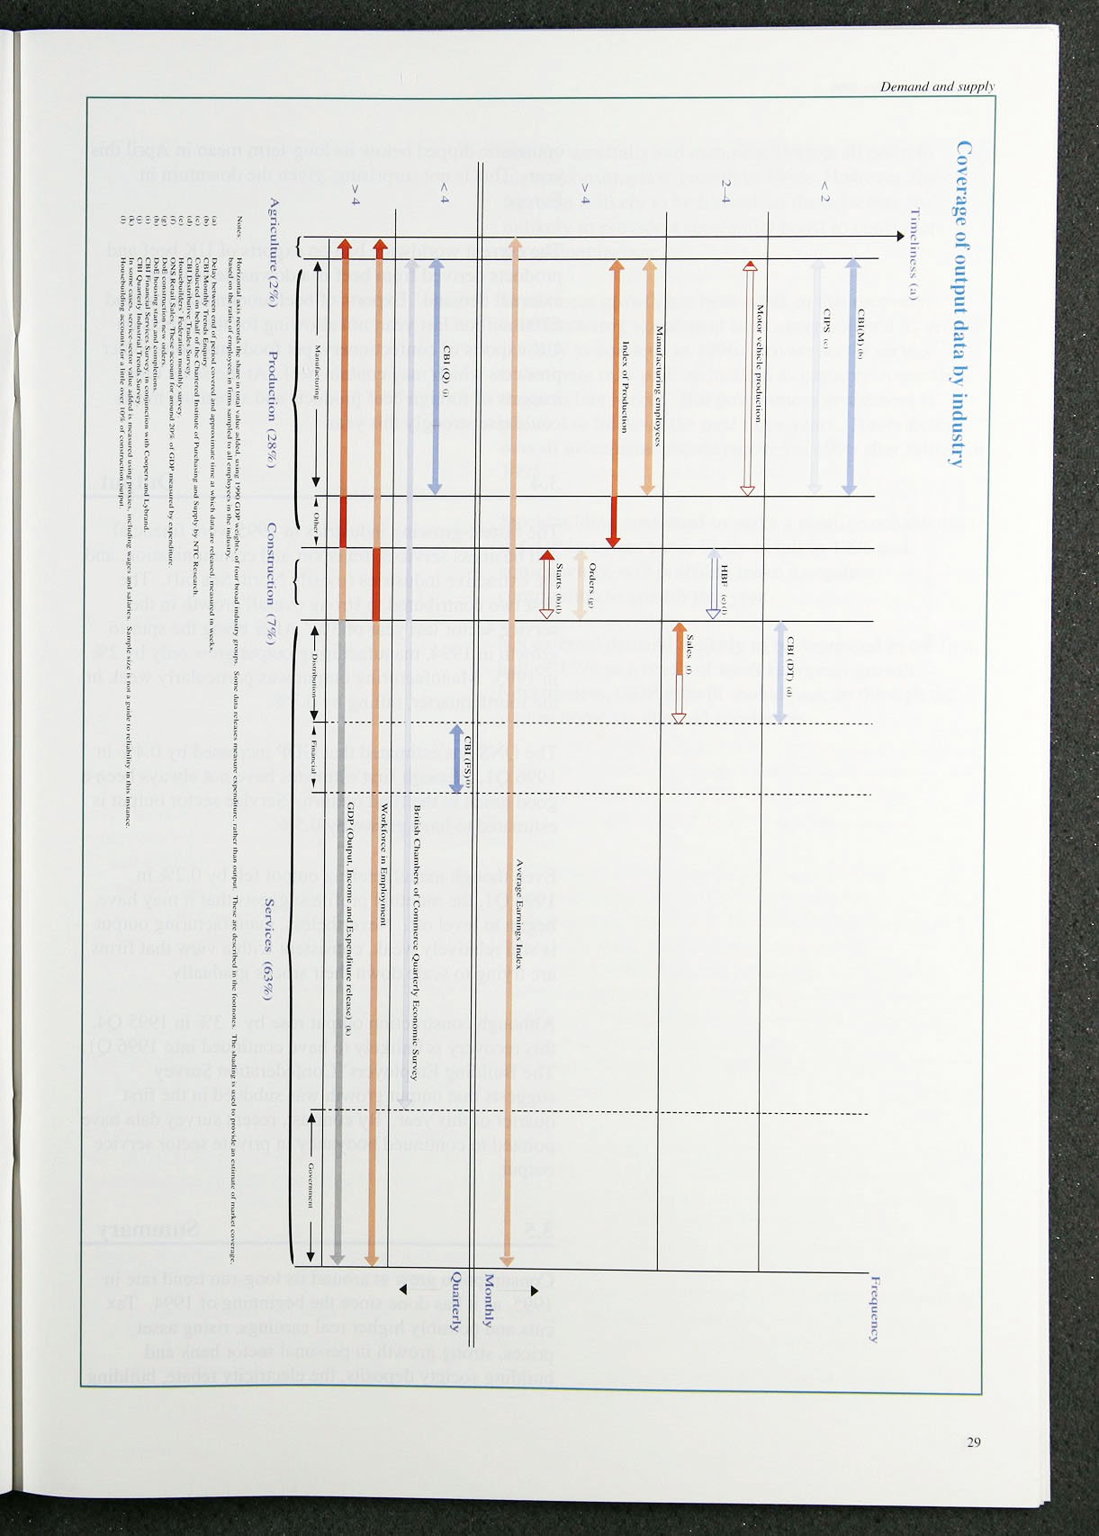

optimistic dipped below .its long-term mea.n in‹Aprjl this year: This.is not su@rising;„.giver: the downturn ,in: Europe.

The current worldwi‹ie ban. on .exports of Uli beef an‹i products lderived from beef is a downsi'de risk for. external demand. Exports of belef amounted to âround

£700 million last.year„ not allowing for the effects on” UK exports of confectioriery,.pet (opds and some/0tlier- products which may contain beef. At the..sa!me.time, imports. of foreig.n .beef pro‹iucts.and. substitute.rrieats could rise strongly this year.



The fastest-growing industries.in 1995; were financial and business. services; transport and ‹ioininunication;land: the extractive industries (mostly Nortfr Sea.oil): The

first two contributed.to strong overal! growth in tlie service sector blast iyear of 30•. After being.the spur to growth in 1fi94, manufactqring. output!gtew on!y by„2âc in 1995. Manufacturing output was particularly weak!in the fourth.quarter, falling ñy. 0.3%:

The ONS. fias estimated: that GDP incr.eased:.ñy'.0.4 in 1996 .Q1, although fiyst estimates haxe not:always’.!been!a. good guide to the final outturn. Se/rvice seétor!output:.is estimated /to have grown .by .0.5%...

Even though!..manufacturi:ng output fell by 0.2% i.n 1996 Q1, the month!ly profilelsuggests.that.it may! have.. begun to let.el loff. .N:.ct /ertheless. ;manufacturingi.output

is still relative.1y.weak; consistent with a.xi‘ew that firms are tryi!ng to scale. down .their. stocks .gradually.

Although!construetion output rose by I.3% :in 1.595 Q4, this recovery is unlikely'to haxe.conti!nueñ.into.l 996 Q1. The I-iui.ldi!ng.Employers' Conféfieratipn Survey suggests .that output %owth was subdued in the. first

,quarter of this yet. By contrast, recent survey data have pointed to continued buoyancy, in .private sector service o91P*!-

## .3 5 S ar

Consumption grew at around its long-run trend rate .in i 995, as it has.:done since .the beginning of 1994. Tax cuts ,and possibly higher real earnings, rising asset prices, strong growth in .personal sector bank and

.’ bui.lding society deposits,...the:electricity rebatei buildiEng .

'



,society windfalls and maturing TESSAS all point to higher consumption growth in 1996. However, the

.increase is likely to .be limited, as these factors are unlikely to provide a substantial boost to consumers’ permanent inclome.

Investment .growth .has been weak in this recovery. Manufacturing investment is an exception and its growth his likely to continue in 1996. Private sector service

" investment may pick up in 1996 as capacity constraints begin to bite harder. But government investment is planned to fall over the next three years. Nevertheless,

.overall investment should recover in 1996 after falling in

.1595.

Stoekbuilding continued to make a positive contribution to GDP.last year, but is likely to fall in 1996 and. conseqi:ently, will probably make a negative contribution to growth this year.

Net external demand is likely to be depressed in the first half of 1996 as a result of weak European growth.

Nevertheless,. **GDP** growth should pick up through the year as domestic demand accelerates.



 

Unemployment fell further ih the ‘first quarter of this

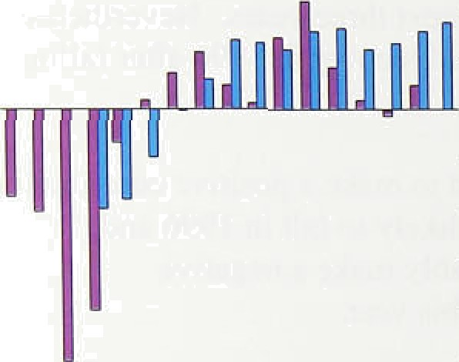.year, .at about the spme rate as.in. the:second half df last! year. Further falls:.in:unemployment contrast with GDP growth around its lo'ng-term ,trerrd.since the.beginni.rig:of, last !year. The puzzle. is explained by the .fact: that total hours worked have.been.broadl.y unchangéd.



’lw‘ii l' ! '‘"'""'“" "’"'"""

’l’iitiil mini i s win lieil per st cck

-_0:0

— 0.6

— 0.0

## 4.1 D:emand fiir labour.

Employment, which.reached a.trough. in 1993,. increased further in the first few months of.ttte yeâr.. There are„two official measures.,of employment. .the worliforce in employment.(WIE).survey:of U.K.employers and'.the Labour Force Survey .(LFS) of a.sample.!of. households.!i!n Great B.ri.tain. According to..the WIE, employment continued to grow last year, but by 'much: less than i!h: 1994, as Char.t 4.1 sbows.. By. contrast,!t.he.LFS recorde.d continued .growt:h in em



quarter last year, and.0:5 r in the first.qiiârter of 1596.

„ „ Previous *Reports* have noted that tlie WIE.may:noi "' record.short-.term contract.and.par.t-time:working as

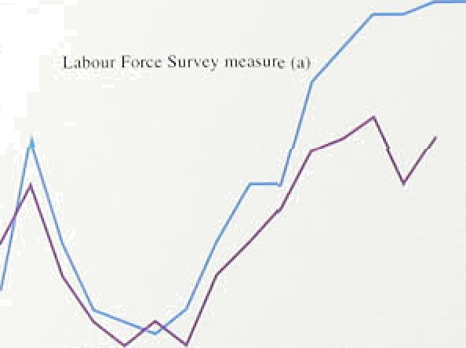

* •' comprehensivei1y as the:LES. These! types o’f w.ork'hañe

_ increase‹i relative .to .permanent ful.l-time work::over‘the. recent past, which rnay!help .’exylai.ñ why the LFS has: recorde‹1stronger empJoymertt.tfian thé WiE. So. the'.

* •'* LFS may provide! a more accurate measure of

- — 825



_ - 82’0



Total hours worked is\a mole:eompreherisivé iñdicator:.of: labour.use. Cliari 4:2ishows LFS and WlE‘rneâsuresi of totals houly /worked. In .contrast:to.the employ!ment data,’ both measures. show tliat growth!in,hours'worked sloWed

‹row.ii .over t1ie'pasi. year. Thé.:LFS”m easure recorded no fihahge in totâl ltours worke‹i i!ii the first.few. months of’ 1995. The explariatiori fs.that.about three quarters ofotliat quarter*s rise iii employment:was in part-time work; and’

;i.iierage.hours worked:by existing eñiployees must have

ial.len.

Th# previous fiepnri'noted.tire contrast between growth

! in. part•time.and full-time work.duri:rig the recovery: As.



since 1993. T is^fixed sample may not.Capt 'the.gmwth of ;i iaii’firms

' jn rajidlJ expanding.sgctors: An anicle in L hour-ñfn@ei.Seri*'dc,*



. more:derail:, Thy,Wlt measure of totaLhours.w.o:Jied epmbjnes.av rage.

hours:dBl'a from ihe LFS.-wiih.employment d$ta. frñm ihe W .

32





Growth-iñ full-time and parfitime-work’over the reco ery‹*



’‹'›

'Emplojiment:growfh:- .construction, maniifacturing ana services



Table. .4.A shows,.full-time employment has barely increased since thelrecovery in output began in 1992 Q1. By contrast, pan-time employment has increased further since the ‹rata available at the time of the February *fiepou‹* according to both the LFS and the WIE. In 1996 Q.1;.!the LFS recor‹ied a 0.1In rise in the number of

full-.time employees, while part-time employment rose by l.4&o. .Bay 1995, part-time wotk accounted for about 289a .of total employment, compared with 25% fn 1990 and 209a in 1980.. The February *Sep*orr noted that the greater flexibility which part-time and contract work provided had enhanced the flexibility of the labour market and was one of a number of factors contributing to a lower natural rate. of unemployment.

Eiiiferences in productivity and output growth between sectors .can help eKplain the relationship between aggregate employment and labour demand. The sectoral pattern of employment also provides independent

.information on output and demand trends. Over the past few years, .the sectoral pattern of output growth has varied! widely. In 1994, for example, manufacturing output rose strongly but, in 1995, the service sector grew quickly. Chart 4,3 shows employment growth in the service, manufacturing and construction sectors.( ) In

!.1995, the number of employees in the service sector rose by about 1180,000, compared with a rise of 35,000 in mariufacturing and a fall in construction.

The. February *Report* noted that manufacturing

-" .employment rose during 1995, as firms adjusted

##### , employment in response to 1994’s rapid output growth,

'• and became more confident that sales would be sustaihed. As.employment ‘caught up' with output,

i productivity growth fell. Over the three .months to

##### * Febniary, manufacturing employment fell, suggesting

, that firms had begun to adjust to the slower output

i».1 growth in l99ñ and early 1996, and that productivity



##### growth would recover.

Constrtictioñ!employment.accounted for about a tenth of

total gmploymeqt last year. Btit the sector is important

.since'capita1,spen‹iing ion housing, buildings, and works accounts !for âroiind„a half of UK investment.

Construction emplpyinent growth recovered sharply in 1993, as Chart 4.3; shows, but i.n 1994 and 1995. firms shed.employees, partly because .of the renewed weakness of the housing i arkét in the'firstlhalf of 1995, as

i1 indicated by,fglliiig housing starts. The fall in





construction employment last year suggests firms had little confidence in the short term.

Sectoral shlfts IN the relationship between output rind employment can affect the relationship for the whole economy. The service sector is an illustration.

Employment in transport and communications has fallen through much of the 1990s, though output grew strongly. This increase in productivity reflects the rapid technological progress in telecommunications. And the shift in demand towards this high-productivity industry coiild increase productivity of the whole services sector.

Survey data confirm the deceleration in labour demand last year and in the first part of 1996. The CiPS employment indicator. covering manufacturing, was below the neutral 50 level during the first quarter of the year. The latest Building Employers’ Confederation report projected that construction employment would fall this year. Manpower’s employment survey (covering the whole economy) was weaker in 1996 Q2 than it had

been a year earlier. And reports about employment prospects to the Bank’s Agents during the first four months of the year were less buoyant than through much of last year. By contrast, the April British Chambers of Commerce (BCC) survey reported a net positive balance of service companies expecting to increase employment in Q2. The BCC survey also reported increasing recruitment difficulties in services in the early part of the year.

4 2 L bo I

The labour force, measured by the number of economically active people of working age, rose by 0.2% in the first few months of the year. Over the year to winter 1995 96, this measure of labour supply rose by 0.7%, compared with a I.4% rise in employment. The

largest increases in labour supply during the year were in those aged 1Wl9 and 35M9; there was a rise of around 140,000 women in the labour force and 60,000 metl.

## 4 3 L bo ket t ht es

Labour market tightness is determined by the relationship between labour demand and supply. In the long run, changes in labour market tightness affect real wages. In the short run, they show up in, among other things, changes to unemployment. Unemployment fell further in the flrst quarter of the year, according to both the clalmant count and the LFS. So according to this

34



measure of excess labour supply, the UK labour market

.’has..eoriti.nued to tighten. And although the pace of

›• tighten.i.rig was less than at the end of 1994, Chart 4.4 sliows that, on a.six-month average basis, the rate ot’ f:Ill

' ' in unemployment has been stable since the first half of



‹

##### 1995,.

As Table 4.A shows, most of the jobs created dui ing the recovery, have. so far been part time. To what extent has the rise in part-time work absorbed excess labour

,supply? During the 1990s, the LFS recorded that a rising proportion of part-time workers would have

preferred to work full time. For example, the percentage  .of part-ti.me male workers wanti.ng full-time jobs rose

from .about 15 % in 1990 to 25% or so in 1995. This means.that, compared with previous cyclical talls in unemployment, the latest fall may have overstated the tightening of the labour market.

Meiisured by total hours worked, labour demand has barely changed i.n recent quarters. It is difficult to

.measure the potential supply .of hour s worked. But since total labour supply—measured by the number of economically active people—has continued to rise, the supply of potential hours has probably risen too. This suggests. there has been little .tightening in the labour market.









’’ lgH ñ 86 87 8#.’8P 90,0’ 92.'7 93’. :.90’9S96

Inactivity rates are a!so a measure of labour inai’ket tightness some .people recorded as inactix’e can be attracted into the active labour .force by economic

.incentives. In the LFS, peop]e aged 16 or over who ai e neither in work nor ;actively seeking it are described as economicall!y .inactive. But Chart 4.5 shows that while ufiernployment has fallen since 1993, the inactivity rate has not: Iri the past, lower .unemployment usually cor:ncided with lower inactivity. The relationship has changeci’bécause of high anfi rising inactivity rates arñong I fi—24 year .olds, as more of this age group have become. students. Th!is partly reflects an expansion in

the supply of higher education an0 perhaps also a change ion younger.people!s: preferences towards gai:nin•_ further qualifications.. Adiverse pay! and employment prospects

‹i.uring the: 1590s havel probably been another ihfl.uenee.!°! If'erñploymefit prospects and relative pay were.to improve,! then sofiie poteriiiñl students would be



°in1roduction'.about

:i.he .unérn'p1oymcnt .c.ohut,

Survey.: roung

lnflution Rcpuri: klay 1.996

likely to j.oih!.the active labour force, so keéping.

,downward pressure..oti earni.ngs,

€’1uirt 4.f›

|JJ0

The iiumber :of 'discouraged! worlers’ 'is also a!n i.ndicator of slack in. the.labour rfiarket. .!n tlie LFS:; they are defined .as people wfro iipuld like..to. w'ork'but liave

.not looked for it in the past four weeks; because they believe no.j,obs are..available. Last yefi„ they aecoi:fited for less than 1% of economically inactive people: The number of ‘discouraged workers’ was still abo,ve its trough in 1990—S l , but overithe year! to /1996.Q 1; lthe number.fell by 26;000 to l 28,000.,

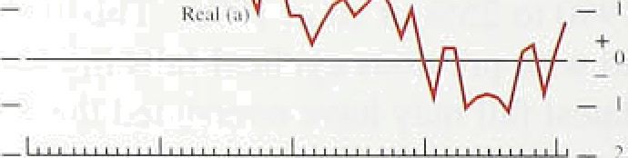The probability workers attach to ,becomi.ng’unemployed is another dimension o.f labour m ket tiglitriess.! As the Febrñ5ry *Sepurt* noted; although:!tie proportion of tlie population with experience of unemploy.ment has not changed much over:the past tefi years; :uneriiployirient became more widespread. across:occupations.d;uring the

.1990s. And, during the 1990s, lthe .LFS recorded an increasi.ng proportiori of part-.time and terriporby contract workers! wantin.g ful.l-ti.rrte or.permanent’work. There..is also .evidence.that, si:nee.the iS70s, job turnover has iricreased and Job tenure, parfiéularJy among iñén, has .fallen. The proportion of:ful.I-ti.me workers quali.fying for statutory! employirierit rig:hts fell froiñ 5.6&• i.n .197a: to 369 !in. 1993.!' :!So the limited evidence suggests that there has.ñeen a rise:in ‘job insecurity’ or in the. perceiyed probability of uneiriptoyrñe.nt aiiiong some groups of worker,s. !f this is inte preted .’as.a fa!l in:



"eorknd. a be ei.s1 h accep! lo **er' age"in** reases than ,otherwise.

## 4 4 Ea s

Gro.wth.i.n“ ave”rage..r"ea l earni"ngs.. p”er.workey (net of tax.), which was.!neg!ligible for most of .1fi94 and .1.995, rose to 0.7% ’in the year,tp: heñruaiy (see Chart .4.ñ). The previous *Ryport* noted that:the.:vreakness of real eamings.

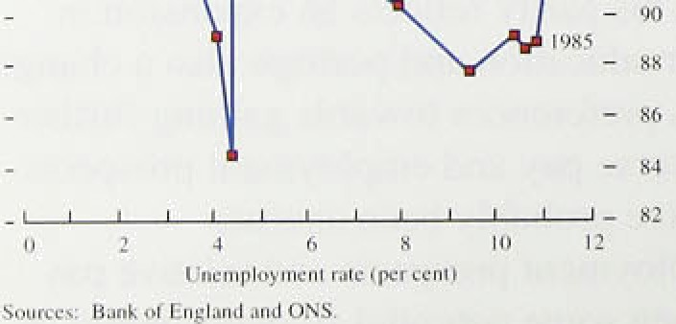

.growtii!was. consistent with...unemployment currently being abode its..natural r.ate. ’Tiiis is›because.as

.unemployment. fail!s, the .pool of potential addi.tional workers falls, ’and‘existing workers are.lihely to demand h;igher reâl wages, confident ,that.if they lose .their jobs, the probability’of their re-emplo.yment is, higher. **’Firms,** by contrast, téind to demand less labour, as real lab:our costs rise.

( l) See Gregg, P and WadsW.oñh;'Jr ’A-. shorl''bistory:of'libouI''turnoxer(!job..



















"V4'

°

W.age:driflt:!› ”



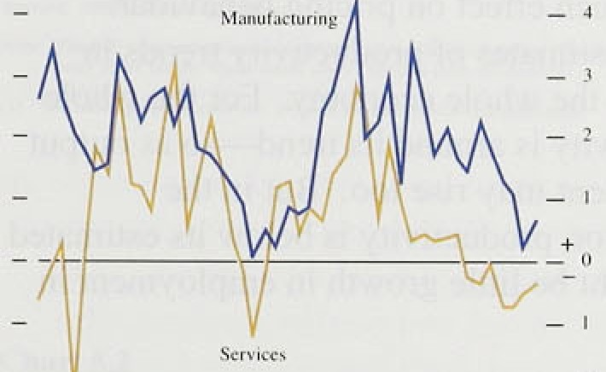



Ifi ttte’ !ongl run, .real wages. are determined by productivity. Over the business cycle, as labour demand

›respofids to changes in the demand for finns’ output, unemployment and real wages adjusted for pro‹ductirity=—would tend to be in ver.seIy related. But as lChan 4.7 shows, i.n the past two years, both u!riemp!oyment and real unit wage costs have fallen.

Th.is is consistent wi.th. workers demanding lower real. wages:at any given .level of unemployment than

b:efore, which in turn is const.stent with unemployment being above. i.ts natural rate. If thls interpretation

is correct, real. earnings growth could continue to be

.lower,than experience of the l97Os and 1'9SOs might suggest.

Annual growth .in .nominal underly ing average earni.ngs per worker .increased from 3'h 'Te to 3'/ 7r between January and February. This was the first rise. in underlying average earnings since the first half of’ l99fi. The underlyinp• rates of growth in manufactui ing and services i’ose in the first few months of the ye‹ii.

As Chart 4.8 shows, service sector earning•s have grown by less than the economy-wide average since 1 993. One factor behind weak service sector earnings last year was lthe di'sappearance of wage drift, as Chart 4.9 shows.

Wage’ drift is usually positive arnings i.ncrease more quickly than pay settlements because eleiiients of pay

.such .as overti.me, bonuses and grading i.ncreirents, rise faster. As the. previous *Reyort* notefi, lower’ bonuses in tlie firiaricial sector in the early part of’ last year pai t1y ’accounted for the lower drift. This year, financial sector’ 'bonuses are likely .to be higher because financial markets were sfron.g in 1995. Bonuses are usually paid within

the first tour!months ofi the year. When this *Re Ann* was

:final.ised:. earnings .data were available for January and ’February:. in. February they showed some reversal oi nega:tive drift in the service sector. which was largely





An.nual pay settlements: weri roughly unchanged in the

:first q.uarter of the.!year: Last y:ear, :about 65'T of all

.settlements monitored by the .Ba.nk occuri'ed in the first four montfis.of,the year,.an‹i 3.4 million employees



,(about half of tiiern in !the public sector) settleci in April, the second largest sin%le mom:h after June. ' Recent

settlements .data are sumrnari.sed in Table 4.B. The Bank’s provisional estimate of the three-month employment-.weighted measure in.A:pnl was..3.:5Fr. the





€’ li;i i-t 4.111

Sci s'icc svclor ciii minds gross th

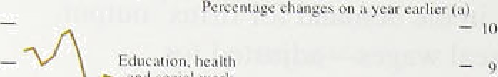

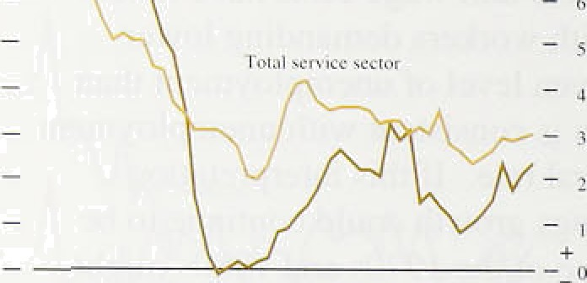







I ! ii it u a;ie crists **and thrir** ctimpnnents



same as at the .end of list year,t 1 in Apt11; three-month erñployrñent-weighted settlernents’in rnanufafitiiri!iig and' services were 3:fi9 and 3.2% respectiyety. The! latest publ.ie sector.pany.re iew announced pay awards for.the 1:4 trillion employées covered by thq.review body. The. awards averaged about 4%. And Chan.4..10 shows tfiat

.since 1993. earniiigs growth in parts of the public sector has.been eons’istenily lower.than iñ the service sector as a whole.: The latest pay awards .may’redhce this gap.

#### 4 Pr d iv w e

Producti.vi;y per head,grew by .I .79 -in the year to .Q4, as Table:. 4.C shows, about tire.same as in lhe.secfind énd thir‹d q:uarteys, though mucli less than over’the previous three years. In the manufacturing sector, annual productiv.ity growth was around 0:5%. iii.the first ,two montlis of,1596; it wks negative toviards the!eiid. of last year,.. M!uch.of the réceni'fall.i.n proñu.ctivity growth las

t)Mpui F.nJylojine nt I.abottr E‹imings per Un cxv'a#e cyclica!, as lthe previous..Repor.t suggeste‹i, so.it is.

unlikely to .have rriuch effect on pricing behaviour.. Chart 4.11 ,shows estimates 1of‹productivity trends!.i.n



ma:nufacctuurriinn.g



an :

who1!e econormriy.

F-or the hole.

*tlanuf0c Iuring induxt r2•





1.7





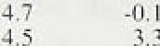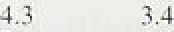

3.9' ' 4:G

econorfiy; productivity. is arountt its:trendsso as.output

the:short: ter:m.



**,-tt'l uai** anti trend **protluctivit'J'**

Wh‹ile economy:

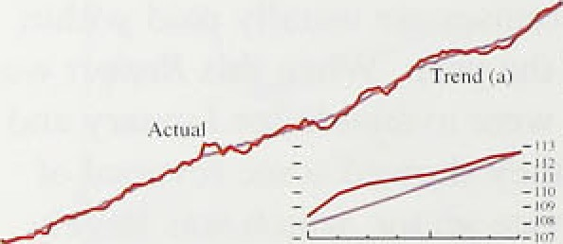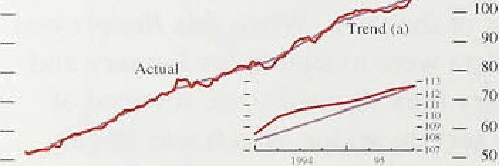

manufacturing

Unemployment.fell furilier; .though at..a sloiver rate than a .year. ago., Employment, pa.rticularly in part-time work and parts.of the service.sector, continued:to rise. .Total hours .worked: per week ivere unchange‹i i:fi..the first few months of.!the year and manufacturi.rig.employment fetl

—bit has now probably adj:usted.to’the output growt!h earlier.in the .r‹icofiery: 'Earnings g.rowth .edge.d up a..!i!ttle in.manufacturing an‹i .services. On balance, .the labour market has'probably not tightened inuch .in tlie past few'

.inonths.

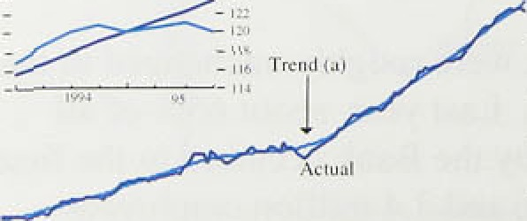

picks

But in Hie









', **Chart 5.1 Iñiport’prices.and.tlie!exchange rate:** .

 

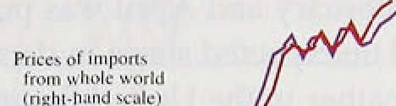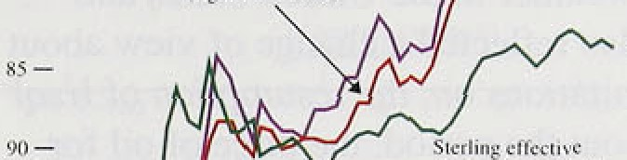

rice indices.









'habit:' aianhJs.'lli*lr dnnt and. iofiirco.



Tire sharp rises.in import and input prices a year ago contributed to a small and temporary increase in output

,price .inflation in the first half of last year. They appear

*:,n*either to have led to expectations of higher future

!infiation, nor to .have become embedded i.n. wage and price. setting.

*5* **T e** e r*r* **ces**

Tfie sterlin!g effective exchange rate appi’eciated by 0.47r between 9:February and 9 May, from 84.1 to 54,4. Since the fall of some 59r duri:ng the lii st half of last year, the effective exchange rate has been. broadly unchanged

(see Chart 5.1).

I.mpon prii:es rose sharply at the beginning of last year,

.:but have .risen less quickly since then.. In F-ebruary, the twelve-month rate of import price inflation fell to 6.47c,

.froin around 10% during most of last year. Import prices arse often subject to. large swings: since 1994, they have risen by more than tire fall in the exchange rate would imply. This probably reflects earlier rises in world raw

:material prices. The extent to which these rises in import prices are eventually passed .through. .to final prices depends on tire monetary policy response.

,Coiiimodity prices„ measured by the Bank index, rose by 3.6&• between:.December 1995. and a year earlier (see Cha:rt 5:2).i' In.the first: few months of this year. incrqase's.i:ri most raw material prices were relatively subdued.. Down:ward revisions to projections of world demahd gtowth:.oder the part few rrionths were probably

::p n.of the:explanation. B!etweeri. December and April. thé. :mean. forecast for:GDP growth in the world economy i:n 1996; reported ñy Conseusus Eéonomics, fell (rom 2:8 to 2.4&•.!° Looking forwards lcoinñiodity price

.pressures could.re:-elnerge i!f reee'fit data indicating stronger activity i.n iapan and the United States lead to

**,upward** revisions to ivorld derriaii‹i projections.









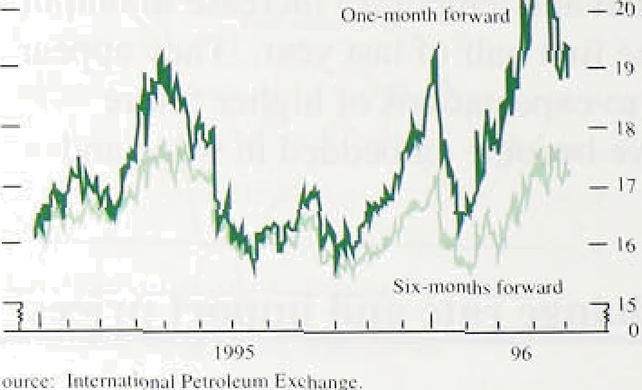

{’I Jduccr inpljl pricr' inl1:tti‹›n and L”l purchase price inclicatnr













”I”al›le 5::5

input and uutput pric.es

Tv.'c l ve-ntonth percentage chunger ta i

Although..increases in most raw materials prices were

:slight ’in lthe early, part"of the year, oil,an‹i wheat.were

.maj,or exceptions. Crude..oil prices rose by latound 35*to* betiveen 9 Febriiary and!.thei:r peak on 1.1 April, :but had fallen by l8& on S May,.to $1’8.80 a:baiyel for Bfefit crude (for one-rñonth forward deliv.ery:). Crude oil accounts lfor:about’a fiftil of the Bahh’s'coininodity index: so movements in' oil:prices are pariiiiulârly i.mportartt. .Although. *cruâe.* oil. is held in s!orap•i', it cannot.1be supplied.i!nstaiifaiieously..on. ‹iemâiid. The.rise in oil prices between February and April wk probably due to a teinpordiy iii‹i unexpected su e in demaiid. after unusually cold weather iii‘the!U.nited States and. western Europe; .it âlso refldcted a change of,view about the. timing.of, and limitations oñ;.the resumption of Iraq.i oil exports. Throughout .the period„..the.price of oiJ..for delivery later iri the yd.ar was. much lower thin that for



World wheat prices"rose by 20% or-so during March and

.April, fol1owi!ng news about:poor h . ests and lori

.stocks. EU prices. teri‹i!t*o âe* insulate‹i from world price movements by the.Coñimoli Agncultural, Policy: B!ut tbe unusually lstrong world prices a!nd poor leather conditions on:.the Continent fiaxe put upward:pressure.on European:cereals’ prices. If this. pressurii persists, there

.cou!l‹i.be some feed:through: to fi:nal retail prices: 1A'nil. the costs face.d by livestock arid poultry farmers, Who use cereals:as animal feed, coiil‹d lnci ase.



##### .In.March, producer input;prices were lower than in September last year; they fell in four ofi the six months to.,March.. The weakness! of input prices is, consistent

:with..the!CIPS. price.i!ndicator which, between November

##### !ai:d Apri.l, was below the neutral 50 level (see. Chart 5.4).

Tti3t measure is,the.perc.e.ntage share ofinanufacturers

##### reporting.a mOoF



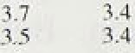.Orting



nseJ MCes they .faee plus half

##### The twel!ve-inonth..rate of producer output price inflation



Ourpul prices

 filling rther toward

RPIX 'i.nflation. .Short-ion measures of output price  inflation fell, too (see Table 5.A). In!the first quarter,



mon:th1y:i:hcreases (excluding foofi; driiik, tobacco an‹i petroleum) averaged 0:1%, compared with 0.4&o.last. year.



40

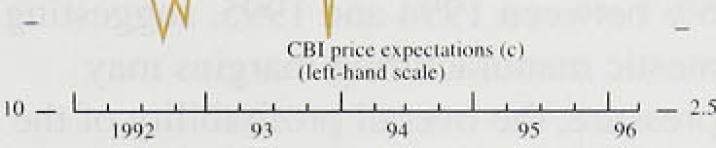The fiBl Quarterly Industrial Trends Survey confirmed that producer outputl price pressures were .lower in the first.four months :of the year than through much of last 'year.. And, in April, the balance of manufacturers expecting to raise prices over the coming four months was still .subdued, .as Chart 5.5 shows. Some of the rises iii raw material prices last year have been absorbed within the manufacturing sector. Consistent with this, lthe treasure of manufacturing output price inflation ñasefi on gross prices (which gives greater weight to the prices paid for goods within the manufacturing sector) fell be!ow net output price inflation in the first quarter— for the first time.si.rice .1994.



.Not all of,the rises in raw material prices in 1995 were absorbed within the manufacturing sector. In the past, raw material food price rises have been passed through qriickty from input and import prices to output prices and on to. final retail prices. One reason is that food is



.subject .to less .refinement and processing than many

.other manufactured products. Over the past two years, the oiitput and retail prices .of food have partly responded to higher input prices—confirmed by reports from the Bafik’1s Agents. Since August last year, the

twel*e-month change in the food component of the RPI has.exceeded RPI inflation. In March, retail food price

.inflation was. 4.7%, compared with RPI inflation of

.2.6 ; .so food prices, which have a weight of around l4% in the RPI basket, accounted for about a quarter of

.the nse in retail prices in the year to March.

The prospects for food price inflation are affected by the reaction .to the government’s announcement of a potential link between BSE and CJD. Section 1

..discussed:the immediate effects on retail prices. Because beef and its ‹derivatives are used as inputs into

,other. foods, the news could have a longer and larger

effect,



ei h o an tab

materials

aiid‘fuels.(inqluding semi-finished manufactured

j3 s.6m” :imports) arid about 'ohe tenth by imports.of finished

i*› m i.a oi;inufactu.res•: lripu{ prices are particularly volatile, so

##### W .es£s. 1 ' : H; , ‹.£. , §s.! i .a:z a1ihpugh:}qp.ut! price pressures.may have eased, it is

o gt› .a _.. , • . n s», xi i:s .intportint'td lonk at an overall measure.of manufacturing



Using.iñput-output tdbles añd assuming fixed



coefficients of pro‹iuetion, it is .possible to ,estiiiiate .the changes over time in each of these costs per unit of. outptit, and so in total costs per ufiii of output.

According to this measure, in. the:first qu!arter. of tliis year weighted costs and domestic output prices rose broadly together, in contrast .to 1.953 when co’sts rose more rapidly.

*In 1* 994, aggregate profitability rose to its highest since 1988: The official estimate! of profitability for tote.whole

.economy in 1995. measured by the rite of return..on capital, will not be publishetl until July: But lGCs profits rose by 5.6% between .1'994 and 1955.,.!su.ggesting that. although domestic. manufacturifig. margins .rñay have been under pressure, the overall profitabil.ity of the corporate sector reri ained higli. This is colisistent with. the strength of thel equity market in 1995:! the -SE

All-Share index rose by .l!S% betweén the!fitstand.last trading days of 1995, and by.S .May it.had.riseñ.by.a further 4&o. And the latest,BCC survey reported a rise in Q1 fn manufacturing an‹1serviee companies’ confidence about future profitabi:lity.

#### 5 Ad n te ed e

The prices of some goods are subject to administrative rules or regulatory review.. Many lutility prices!are revieweci .yearly, with new prices effecti.ve..2om! the beginning of April. Price.,changes are often linked to the RPI. This year’s increases in electricity and water charges are little changed from last ye.ar and.are unlikely to have much effect!:on RPI inflation. .By contrast, the Council Tax, which has a weight .of about 3%.in the RPI basket, rose by an average S'/‹&« from April this year in England (and by'more.in Scotland and Wales), a’ slightly larger .increase thap last year. And tlie price .of postage stamps is to rise by 4 —5% in Jmy; their iveigiit:in .the RPI! is 0.2fio... On!:balance however, .!avérage administered price i.ncreases be Jikel.y.to remain.below iiea‹iline **RPI** inflation o,ver the coming few moriths.



Short-run tneaiures ofi costs’and prices in the

.manufacturing sector have.leased further. . Downward revision3 to world growth projectiohs may have helped relduee! i.ridustria1.co odity price .pressures: Oil and. wheat..prices rpse,.but this.was .largely due to teniporâry

.supply shortages.. Costs. in the manufacturing .seetor rose faster than domestic output prices 1ast’year but in .Q4 they. rose!.broadly together.





## e6nd

The Ba k

e o e t o

|  |  |  |  |
| --- | --- | --- | --- |
| : | . |  | Real output growth during 1995 is now estimated to  .have been steady at around '/i% a quarter, close to the |
|  |  |  | average growth rate of the economy of 2,4% a year since |
|  |  |  | 1548 (the first year of the official series for GDP). Revisions to the data changed the apparent profile of |
|  |  |  | growth during 1995, but left the estimated GDP at the |
|  |  |  | end of the year more or less unaltered, so the economy  ,entered 1996 with about the same demand relative to |
|  |  |  | potential output as was thought at the time of the |
|  |  |  | February *Report.* |
|  |  |  | .The.February *Report* identified two downside risks to |
|  |  |  | activity in the Short run: first, a period of destocking, and second, a deterioration in major export markets. The first risk has not yet materialised, although a reduction in stockbuilding is likely during 1996. A downturn |
| . . | ’ |  | triggered .by destocking is still possible, but it now seems likely that firms will gradually use up their surplus |
|  |  |  | stocks. by increasing their output more slowly than any rise.in demand for their products. |
|  |  |  | The second short-term risk to activity identified in the |
|  |  | ” | *Feb*ruary *Report* has materialised: exports are lower as a result of a!slowdown in Europe: There were further |
|  |  |  | large ‹downward revisions to prospects for demand in Gerriiafiy; these have adverse implications for growth in the rest of the European Union, an‹i for UK exports. As a.result, during 1996, tltere is likely to be a switch from |
|  |  |  | net exports to domestic demand. There are already signs  .of this fn the trade and GDP data available for the first |

uarter. The iiiedium-term prospects for net exports de. pend .on the.d:mation of the .slowdown in Europe, particulârl.y Germany. That slowdown should be short-lived, partly because of the easing of monetary

pnlicy ‘in much.of Europe iii recent months, although its duration wlll **‹iepeii‹i** also, on the qffeet of.fiscal

**ti tening designed to** meet the Maastricht deficit

###### erilerion.

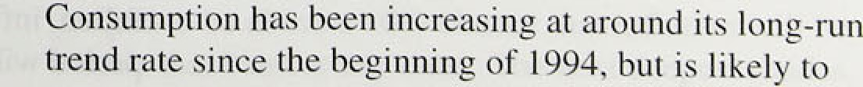

the:outlook for.aggregate demand on consiimption, the.largest component.

lullatiou Rio t May 1996

accelerate tliis year. ,One reason for itliis iscthe;strong growth of.indifiiiluals' M4 balances, at an ahnual..rate of around 79n in the first quarter of this year, compared to

.nominal .consumption growth dunng I st yoariof below 5%. Receipts .treated as ‘windfgll' gains ,wiiich ;;;o1ude the recent electricity rebates and but.lding.society payouts may be spent partly on eonsumer!durab1es;. consumption of non-durables should be less affected.

But growthyrates of realm earnings.and personal Asposable income are likely to increase.t1i1S.year, winch will tend to raise non-durables consumption.too.

Investment fell last year, accounting for about 40% of the—roughl.y one and a halfi percentage point fall i!n the annual growth rate:of.GDP between: 1S!S4 and l!9S5. Even l.ncl.uding Private Finance Initiative projects; total publicly sponsored capital investmentlis. likely to!decline in real terms in each of the next three years: .However, ICCs’ profitability remains high, as dpes the.!ratio lot equity prices to the price of.investment goods.. i3oth factors imply that there is an incentive for firms to increase .investment. Also, the.rise. in ICCs‘ M4:,deposits in 1995 Q4 continued i.n 1596 Q1—at.an. annual growth rate of around 79. In the past, such a rise has signalled an.increase in ICCs’ rates .of.investment. The February *Report* noted that strong ICCs’ borrowing!, if it were.to. continue as mergers an‹i acquisitions acJiyity subsided, would suggest an acceleration in. firms'.nominal expenditure. In .1996 Ql, takepver activity.eointihued at a high level. The net sellers of equity in the,acquired companies may purchase other.financial.assets;

central case in .the projection!:below but.they may! spend the funds. instead on..goods:and services..

on the supply side of the UK economy, the two issues

.identified.in..the February *Repo* rf remain relévant, First; real.earnings growth continues to be surprisingly lo:w„ râisihg the'!possibi.l.iJ that the iiatural .rate of

unem lDyment,is,lower thair.in the.. l980s, In February, thé’average earnings index, ,deflated by the..tax anfi! price index, was only.0.6& higher than tiiree yéars ago, when

.unemployment.had just..passeñ.Its peak. ’The s1i!ght

,pick-up in real earnings. at,the..beginning qf 1996:can be explained.by. larger.bpnus, pay!ineiits this. year than last. An‹i preliminary data sugg0st‘fhat the level of settlements was uhchanged at *3.SP* in April, despite ublic secto{ reyieg body pay awards ghove thiâlevel.

If the namral rate:of iinemploymont does‘ furtf out tfi h t **fallen,** inflptioñ pressures. throughout tire! **for£‹nft** périod will bg weaker than. iti the central projection,





   96-” 97 ' 9.i.

Chart 6.2

**RPIX inftutiun projection in February**

ñ' Incna e in r'ccs on u cur carlic r

03 94 95

Tb'e'cliort sb ivs'.the:relati .e..'liEeliho,od of p'ossible.:qutcome,s. Tlie central..bank,; coloured deep red, includes the control projection: I hert is. judged to be:about:a’ U% chanc .ikcit inftatioii'will’.be within ’that ccritral.band at bny’date: The next deepest shiide, on both sides uf the central band, takes the, disttib,iitiorrout.,to 20. end..so o.n, .in! steps..of.ten ,pe,rc.entage. points. Of..course. ii is impossible.to asscss the probabilities with any precision.

,but this represents. the. Bank’s b,esL eBlimaye'. The. mem ulioeriaintJ theré-is.about.ifie inflation outcome at anJ parlI'cmar rime horizon, the wider the

bands„ and thu more gradually the cmour. fades. And; if the. risks are'.more, on-.one sidg than the. other, then .the remaining bands n'ill be wider on tttat ’ slde Sof:.the.,.cent(at ba*,d:

Second, the Bank’s projections assume that margins in the retafl sector, which fell because of increased

.corñpeticion, will .remain around their present level. That assumption .is reasonable because retail margins do not appear in the past to have varied systematically over the

,business cycle.

The .B!ank's new medium-term projection of RPIX

,i'ni1ation.is shown in Chart fi.1; the February projection

.is›siiown in Cliart 6.2. As usual, the projection is based

.on,the assumptions that official interest rates remain unc1iange‹i,over the next two years and that the effective

.exchange rate evolves according to differences in iht’erest rates across countries. Public spendirig and tax rates!.are assumed to follow the.profile set out in the

' Nov’ember 1995 Budget. .As explained in the February *2teport;* the chart shows the Bank’s view of the probabi.lity distribution.foF inflation outcomes. The

' ' central.band in "the.chart; with. the darkest shading,

includes the central projection for inflation: there is

)udg to be aboutla 10a chiince that inflation will be

Cthiii that band. at any date. The.next deepest shades,



L"h‹irt fi.1

IJixtl”illt ti‹›n ‹›f” ltPIX inf1ati‹›n tnreca*ts

l'or l09f› t)d







lvi.striT1uti‹»\ ‹›f” It PLX inflation f’nre«asts



on. both sides of the.,central! band, take. the distribution. 'out to 20%;, and.so.on, ‹in‘steps of ten percentage points.: The.width of thg .bands. in Chart 6.1.gives an indication of lthe uncertainty.aboi:t inflation over!the next two!

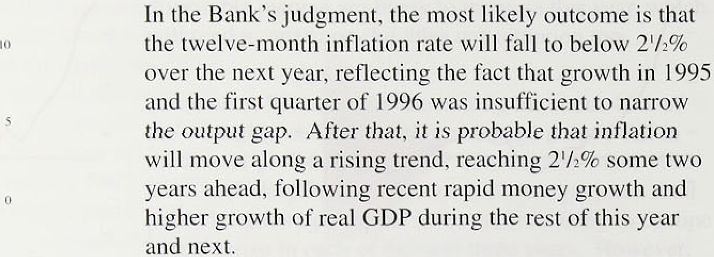years. while the as.ymmetry clothe banfis -indicates the balance of the risks around.the central. projection (1)a In thi.s .way, Chan ñ.1. i:l1usctrates,the degree!of.uhceftainty stirrouridi!ng the central.projections.,

As ih February;..the maj.or.:uncertâinties!surroundi!ng the

central projection nag



.acceleration. In the short term, tire risks to the projection are skewed a little:towar‹is the idownside the’piek-tip ifi! growth may.,be slower..to.arrive than expected.. But.: towar‹is the two-year liorizon;!,t!be risks .of:rapid eonsumptiori and investment .growth!are greater,. afid the risks are more. on .the.upsi0e.. It is marginally rimore

li.kely than not .that .inflation .wo'ultl be. iibove 2"/ &é.in.. two years’ fime were.official ratgs to. iremai.ñ! unchanged

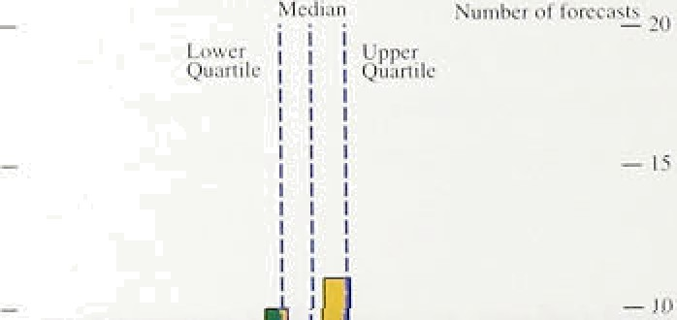

a little.higher than RP.IY:i:n:Hatton ñecñuse on balance,

, taxes affecting.RPIX'.are lijie1'y/to increase faster.than R.PIY .in.flation: 1.ln particular, the. govern.ment has annotificed.plaits io tncrease..the real rate of fuel taxatioii,

— • and the..Council.Tax .is:.assu riled..to..rises. broadly in. iine, with local authority pay; rather than with.prices,



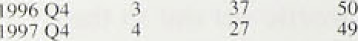The.new.ce'ntral projectioii is similar ter .tlieione made::in. February, extended by, one’quarter’(see’Chart 6.2):. ’The deterioration since February .is offset by stronger domesticl ‹Fernand in the outlook for UK exports, partly in response to recent reducltions in .interest rates. As in’ February, the downsi‹le risks are mainly in.the near term; now one quarter later„ they are less likely to affect the



!out1ook.in‘ two’ years* time. The.upside risks apply also.





net.eNect of moving the projéction. forward:one quarter is to:give greater Weight to the upside ri.sks:to inflation.,

,'('l) The. more uncertainty. there is about inflation:g1 anti parriéutar'time'” ' ’

.!hoIIzon. .the, wider the 6ands. and”the.more.gradually tlte cd1om.fgdes. :lf..



oo1hat&(de.





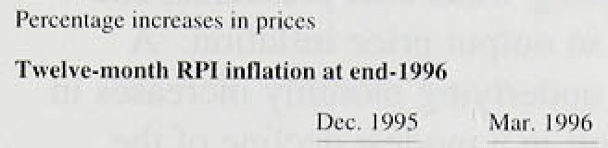

!ndimci«t-azt8ty;is .. ’ ” 3:0’ 3. I







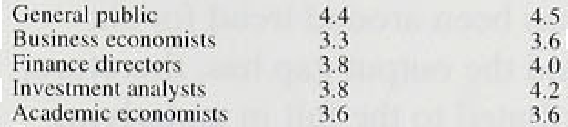



















## 6.2 Outside forecasts

Among the .forecasts regularly monitored by the Bank,

.inflation eKpectations have fallen slightly at both the 1996 Q4 and 1597 Q4 horizons. The median outside forecast for RPIX inflation in the last quarter of this year is 2.7&a, .down from 2.8% in February (see Chart 6.3).

Differences, of view are a little narrower than before: the inierquartile range—the range of central projections eKcluñing the highest and lowest quarters of the distribution—contracted .from 2.5%—3.0% to

2.5&-2.9%. Extending the horizon by a year, the iiieciian outside forecast for 1997 Q4 has fallen from 3.0In to 2.9%, and the corresponding interquartile range from 2.5%-3.3&o to 2.6&o—3.259a (see Chart 6.4).

A .subset of forecasters have again provided the Bank with i:nformation about the probabilities they attach to various possible inflation outcomes. Table 6.A siimmarises their responses. As in February, the range

.of uncertainty around most forecasters’ central projections is similar to that of the Bank. On average. they tliiñk it more likely than the Bank does that

.inflation will be over 2'/i% by 1997 Q4; but judgments vary from a probability of l9&o to one of 91%.

Tlie latest Barclays, Basix Survey of inflation expectations among different groups shows a fall in 1!mean expectations of what .in.flation will be at the end of 1996 (Table 6.B). So does the Merrill Lynch monthly survey of UK fund managers (Table 6.C), corroborating

.the findings reported in Chart 6.3. But at the end of “1997, the Barclays Basix numbers indicate a small rise

.in inflation expectations, while the Merrill Lynch ones point to a small fall.

.There .i-s li:ttle..ev.idence to suggest that expectati.ons of inflaoon up, to the end of 1597 have increased. But pnces in the markets for conventional and index-linked gilts !1mply:that.i.nfiation expectations over the longer

.term have risen in the.past quarter. Chart 6.5 shows ealen‹iar-month averages for estimates of inflation expected.five and.ten years ahead; the five-year expectation teas risen ,by over half a percentage point. To some extént„this. ma:y. reflect: an increase in .the risk

premiii:m..paid. for.in‹iex-linked gilts.rather than a true rise in inflation expectations, because bon‹i market volatility generally has increased. But i1 iS not clear that

*noertainty sp iiically'aboiit:inflation. has increased,.so



**l0ltg-térm** inflation..e›ip Stations ha:ve nsen.



6.3 Conclusions:

Retail price inflation! was stable orer the past three months.. Manufacturing output..price inflation, in.. contrast, fell to an lannualised rate,.of about 1&a liver the past quarter. Company.surveys, .CBI.and Glrs (or example, report continuing wéak cost pressures, an‹i little sign of an upturn.in output:price inflation. A continuation of recent underlying.m onthly increases in retail prices would result in a modest ‹recline of the twelve-month. inflation rate,over the rest.of this,.xear to! below 2.5&r. The mafn.risk to that prospect is.tlié. sensitivity of food prices which make up, 14.9• of.the RPI to unusual seasonal or other factors (such as BAR).

Non-oil output growth has been around trend tor six.. quarters. Over that period the .output.gap has, therefore; not closed and has contributed to the!fall in underlyi:ng. inflation, The main short-term risk is to sectors. dependent on exports to Europe whe growth prospects have been significantly revised d9wwards since!the February.Report.. But.the continuing grow:th.of broad. money suggests that ldomestic demañd is likely:.to: accelerate over.the next.year or1st because.of growth in personal consumption and corporate inxest me.nf, In real. terms, broad money growth increased from,arouiid 2fi« in .1994 to 7% i:n 1995 a:nd further.to:9 in.the first quarter of this year.. Paid of the recent.acceleration„is accounted for by a structural!bre , iti. t1ie.series following.the introduction of a gtlt repo market.. But whatever adjustment.is made for that change,.!.the picture

.remains one of rapid.ñroad .money growth onsisteñt with.the centra1,projectiori of.an.acceleration of domestic demand.from the end of this year.

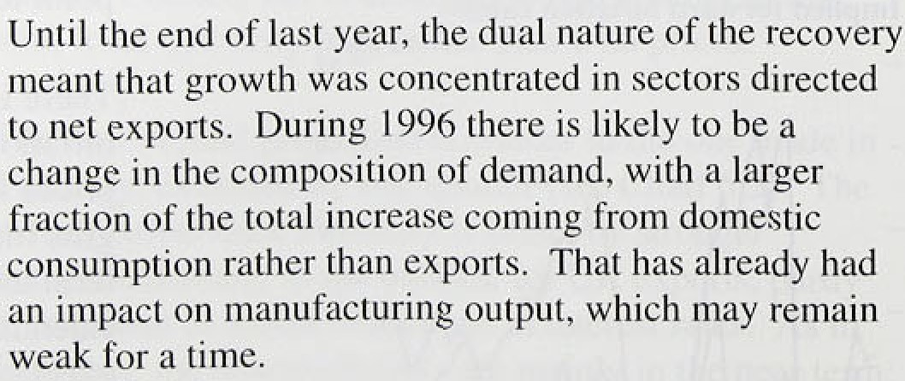

The Bank’s.latest projection!f.or iiiflation-lwo yaara, ahead shows inflation rising to around 2V*%. in

mid-J998. As in February; the risks in ttie short term

. more on the downside, but ao far neither loWer stockbaildimg nor lowor exports have led to my noticeable falJ in output growth. .As a lili,’@tiyQugit those iisks,reniain, they now seem les‘s seriauâ, grid with

48



lhe passage of time they will, if not realised, disappear from the picture. It was precisely at this juncture—with apparent short-term weakness in some sectors masking signs of more buoyant future activity—that policy mistakes tended to be made in the past. That is why it is important that monetary policy continues to look fOfward and to focus on meeting ihe inflation target.

The current projection shows that there are risks to the inflation target two years ahead, but the appropriate response depends on how the short-term downside tisks evolve over the next few months.

4é

### Glossary and .other information

**Glossary of selected terms**

**RPI** inflation: inflation measured by .the .retai1,prices infiex.,.

**RPIX** Inflation:: i'nf1ation.measured.by lthe RPI excluding

:mortgage. interest payments:

**RPIY** inflation: inflation.measured. by.fhe: RPI excluding mortgage interest:payments. and...the.:following::indirect.ta:xes:' the..Council Tax;. VAT: ‹iuties;. car:purchaseo:tax..and.vehicle ehcisei duty, insurance.tax and airport tax:

**HARP** index:. a price. intiex which 'replaces,the inortga e\ interest. payménts in the RPI with a Bank estimate of the ‹user-cost of housing:

**THARP:** index: the.HaRP'i:ndex .Excluding indirect: taxes.

MO: notes and coin in eirculatiori outsiiJe lhe. Bank of.England and bankers! operational deposits at the .Bank..

M4: UK non-bank, non-building society pprivate sector’s holdings of notes and coin, together with all sterling deposits (iticltJilihg: certificates of deposit) held with UK!.ñaiik:s:*nd building societies by the. non-bank;. non-building. so.ciety:private,seictor.

Divisia money: .a measure of thel money!stock in which each/ component is weighted.according..to an..estimate .of h.ow useful.lare the transaction .services it provides.



Three-month **gnnualisefi:** lthe.percentage change .in a series between one period:and that tbree.rrionths:earlier, éxpressé‹i.as:an annual rate:.



Symbols **and conventions**

Except where otherwise.:stâted, the.source for the data used iñ

.charis and tables is”the Office:for National Statistics.(ONSj.

.The measures of inflation in luded ,iirthis'Report. ha ct been. adjusted.by !tlie. Bank:.for qn .errnr.by: the'0NS*pred@essor, the

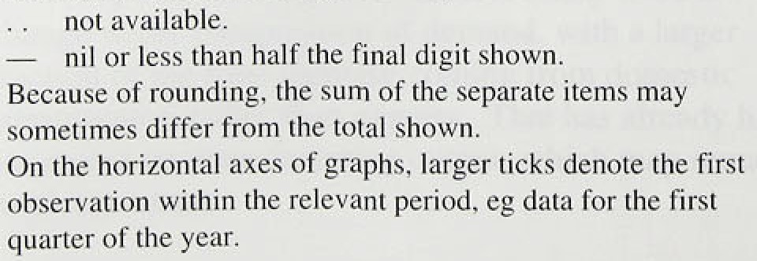



:. Emâil: ^mad1vSBdircon:co:uk

'The.Suinmary 0f’this ’A*ef on* is avai!lab1e at: htrp:ffwww.bankofengland: co, uk



Price fi3.00